NEXCOM Merchandiser Duties Handbook
Table of Contents
AD Database 3
Asset Worksheet (Put items on the Web) 5
Case Pack Change 6
Change Forms 8
Communication Request 10
Cost Changes 11
Fact Tags 12
FF PO’s 13
Frustrated Freights 14
RA’s & Call Tag 15
Item is not on PO. 16
PO not in system 17
Over shipment 18
Item Inductions 19
Computer Descriptions 19
Special Order Items 20
Drop ship item inductions & store. 20
Displays 20
Add Supplier 21
Item List 22
Creating an item list manually 23
Creating an item list 24
Item list RMS V10 26
Item Reclass 28
Mail Package 29
MSA 30
Promotion Template 31
PO’s 33
Delete item from PO. 34
Price Change 35
Product Images 36
Person of Contact 37
Quick Reference Guides 38
Color Codes 38
New Vendor Web Brand UDA Request 38
Hardlines Web Naming Conventions 39
Buyer Numbers 39
Store Locations 39
Ranging Items 40
Serialization 41
Single Items 41
Mass Items 43
Store Order Multiple (SOM) Change 45
SQL (Structured Query language) 48
Vendor Allowances 51
Email Chargeback 53
Report to DMM – Jason 54
VADB POC LIST 54
Website URL 55
Who can help? 56
Consumer Tech Merchandiser Specific (Ryan) 57
AD Tracker 57
Apple PO’s 58
Apple – Best Buy Price Match 60
Hardlines Buyer Promo Report 61
Promotional Fact Tags 64
Jenn’s Weekly Reports – March 2026 67
CT - People of Contact 71

AD Database
OPEN
- Template Download
- Advertising Week Folder
- Ad Tracker:
- My Template Location
- In-Depth Guide
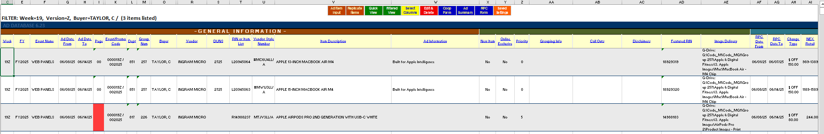
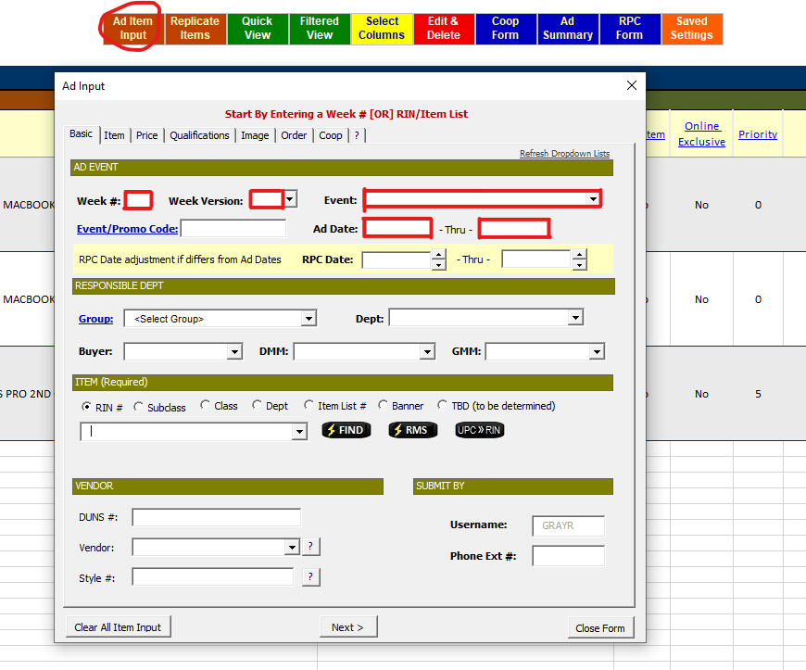
Rin input will auto fill dept information.
Fill out all tabs at top then ad will input. Quick view to refresh page.
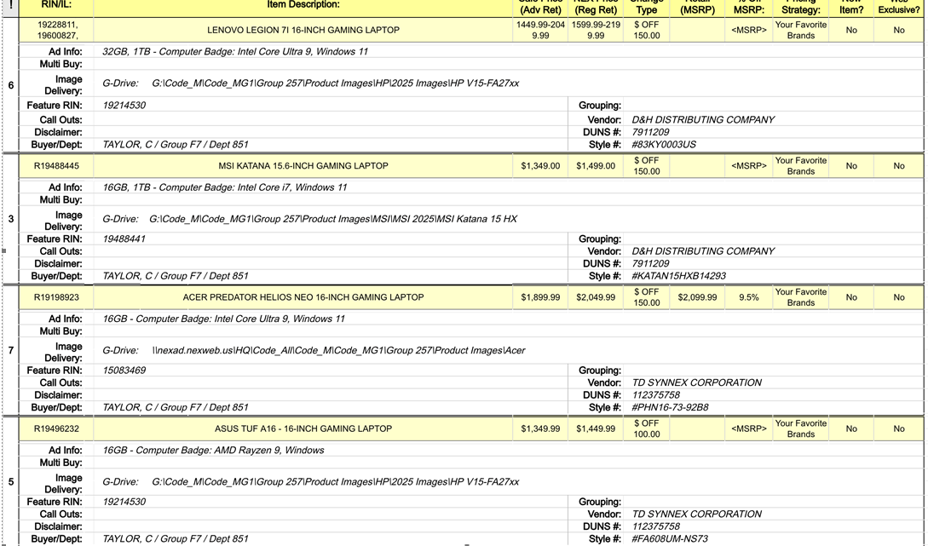
Top of the Document

Asset Worksheet (Put items on the Web)
Open
Send worksheet to vendor so they can fill out information for columns J-U
Get link to images. Images must be named according to parent rin followed by color code.

Case Pack Change
*Case Pack Download from RMS must include Trans and Parent Rins.
Case Pack can be changed in V16 if the item is not stocked in warehouse.
If it is stocked in warehouse. Then,
- V16
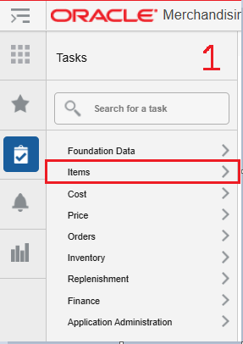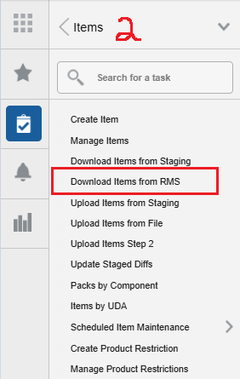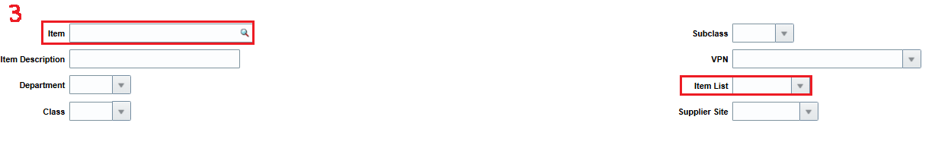
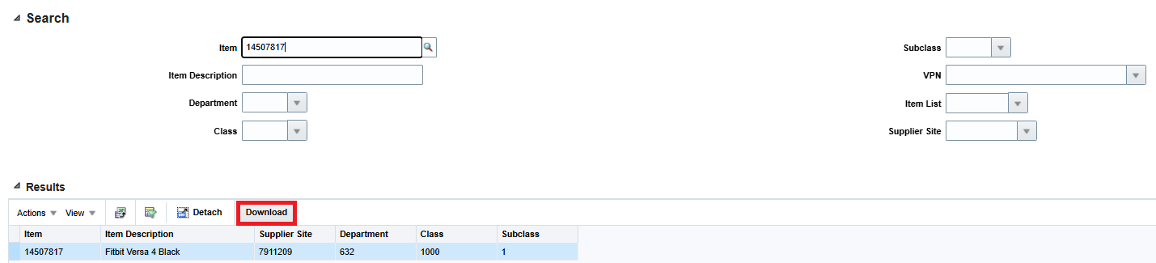
For one item or item list for more than one item
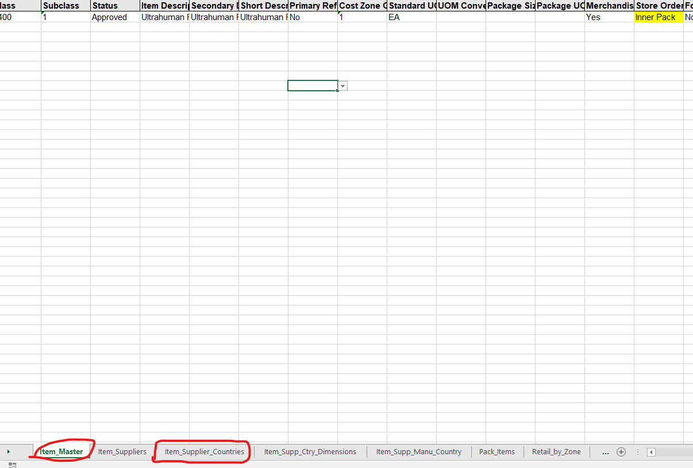
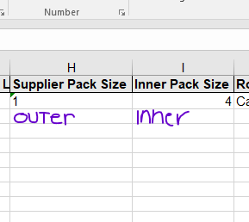
Send to DST when changes are made.
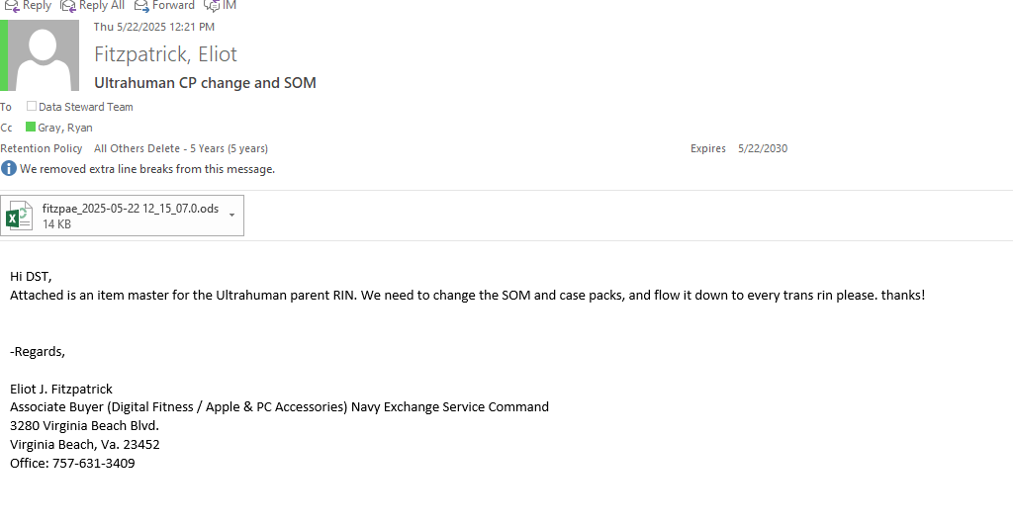
Top of the Document

Change Forms
OPEN
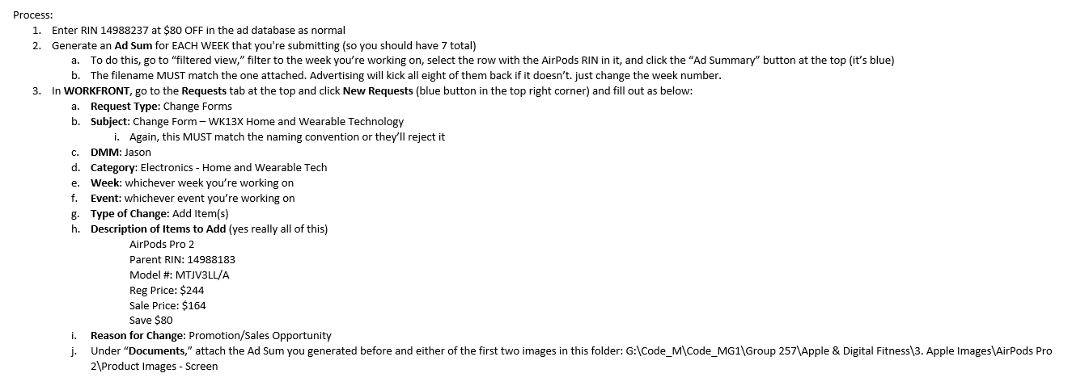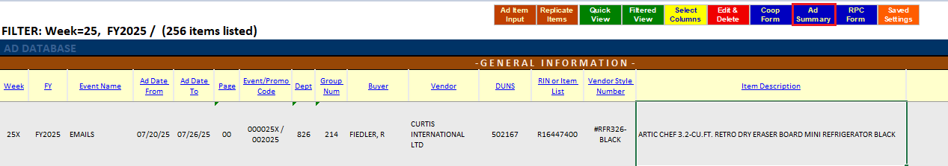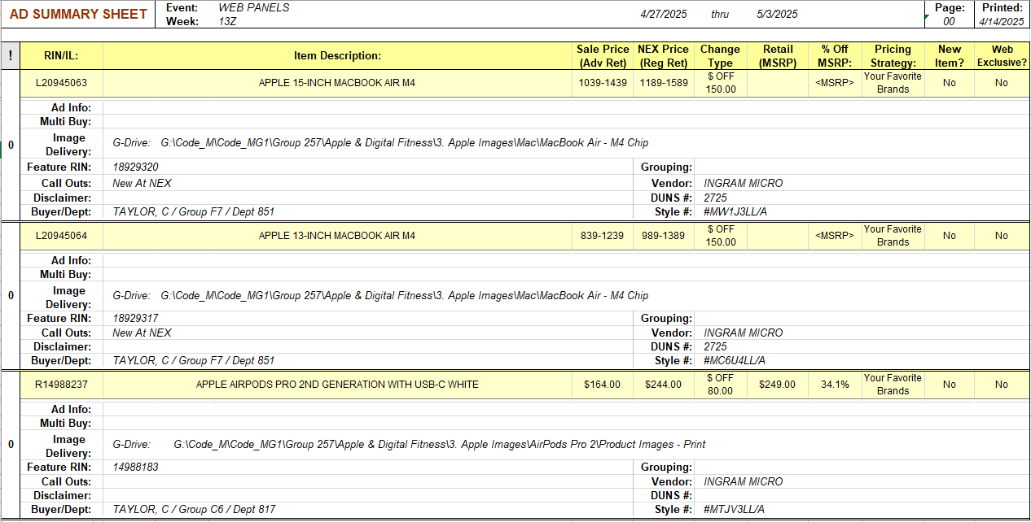
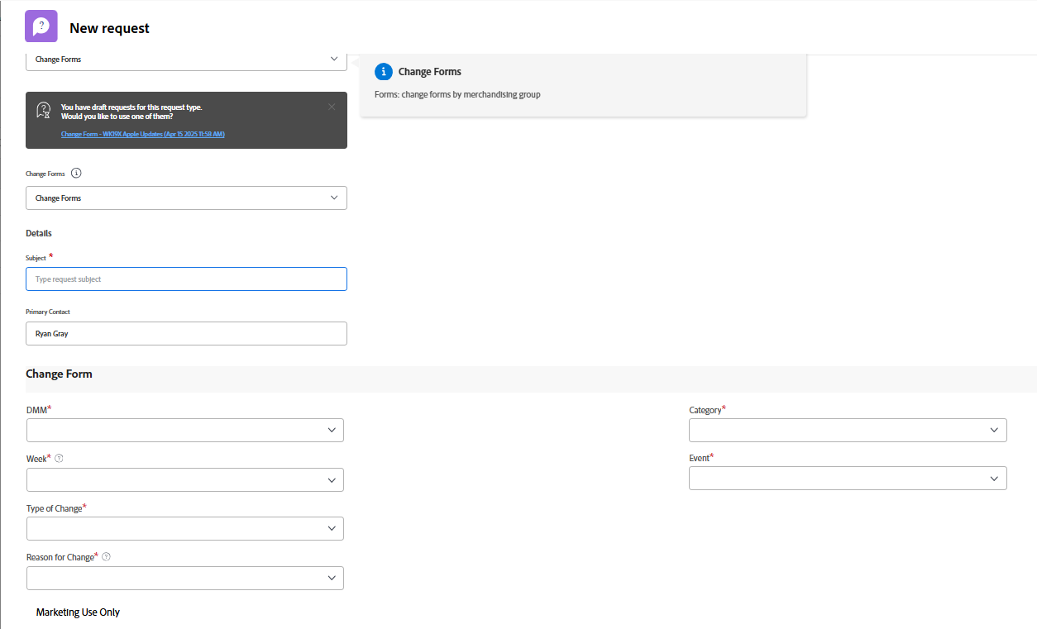 Workfront
Change forms for multiple items over multiple weeks can be submitted in workfront under one request if it is under the same event.
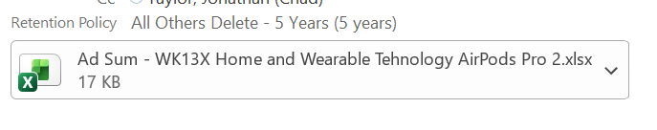

Communication Request
OPEN
Communication request Template
- Fill Out information in form.
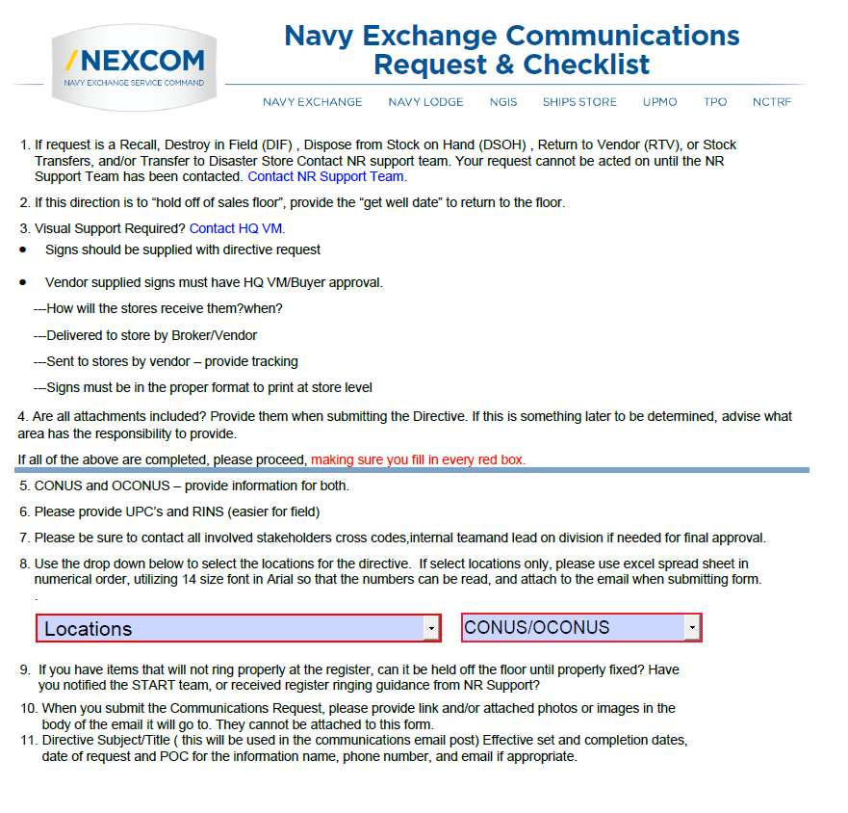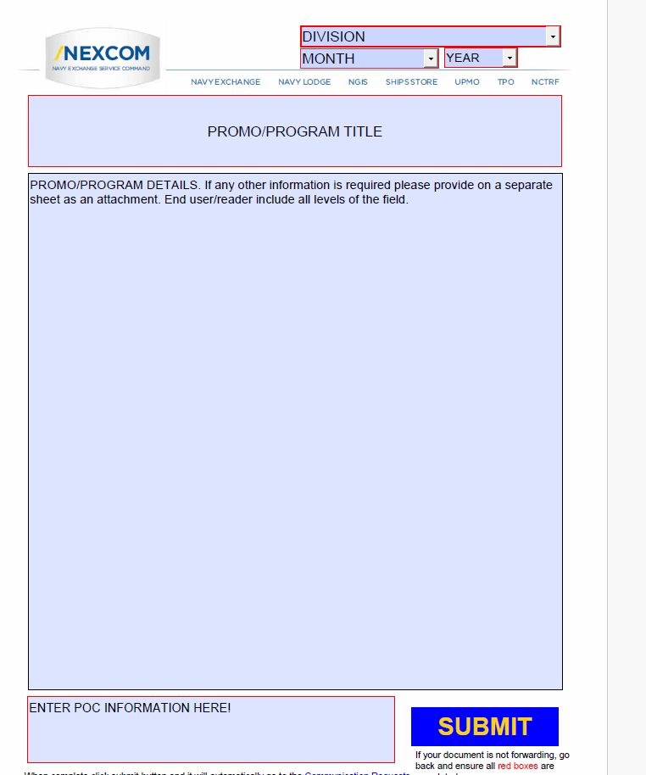
Hitting submit will pull up the email to the communications team with the form.
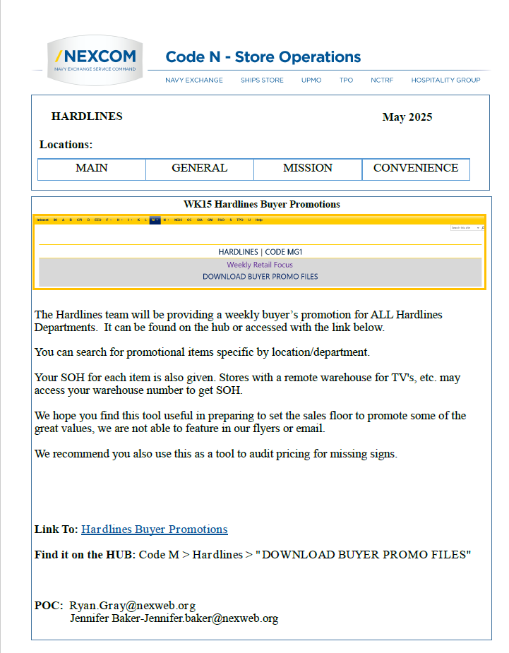
Top of the Document

Cost Changes
OPEN
- fill out template.
- upload template into V16.
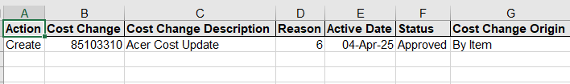
1st tab
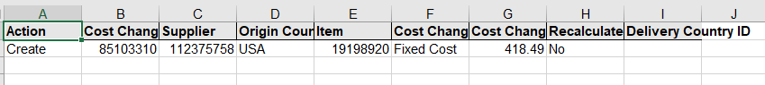
2nd tab
Upload cost change into V16:
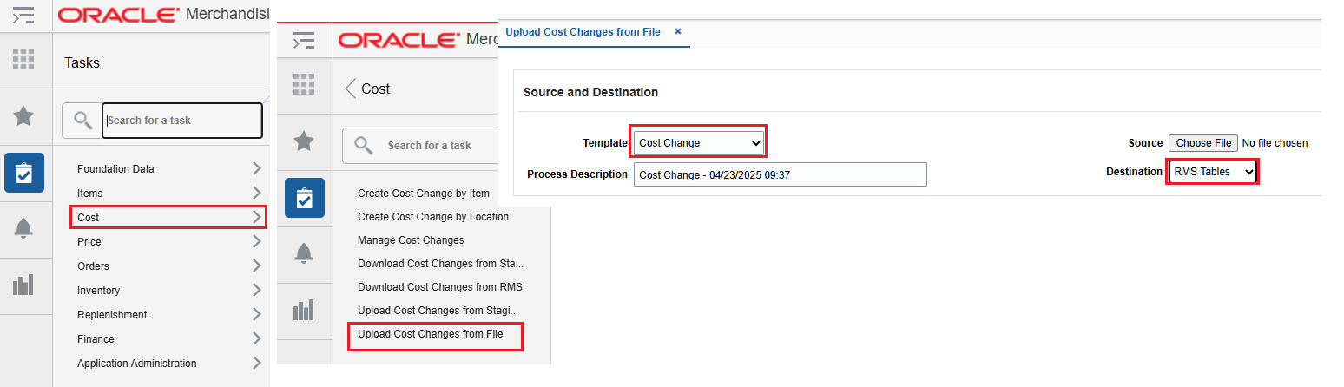

Top of the Document

Fact Tags
OPEN
My Template
Consumer Technology Division Fact Tags Folder
Example Fact Tags Below
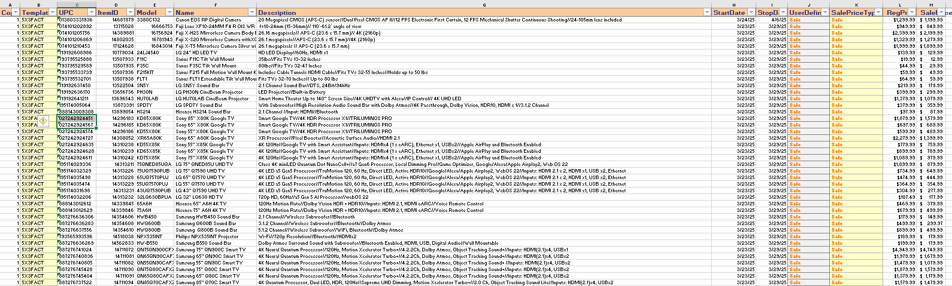
Update and save to Folder:
Email to Plus sign team.
Ask for latest items to be inducted.
Top of the Document

FF PO’s
OPEN
Important note: For “PO Type”
- means the merchandise is at a Distrobution Center (DC) and needs to be allocated to a store location.
0 means the merchandise is at the store’s warehouse.
Reference below for merchandise at store needs to be allocated to the store.
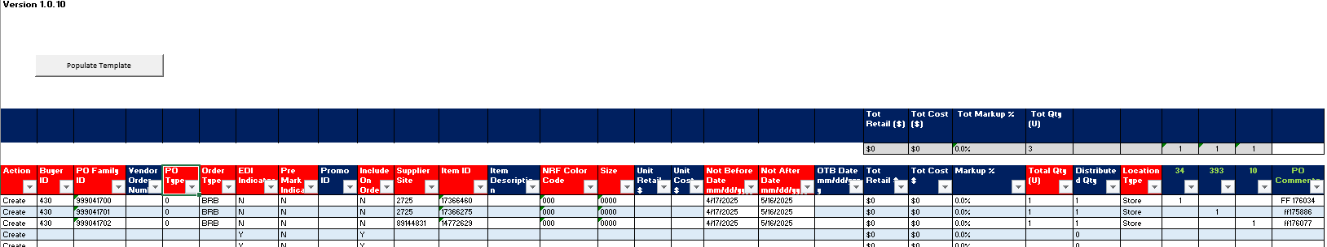
Reference below for merchandise at DC that needs to be allocated to store.
Save to
EXCEL: Folder
ODS: Folder
Top of the Document

Frustrated Freights
OPEN
StoreManagementUtility Download
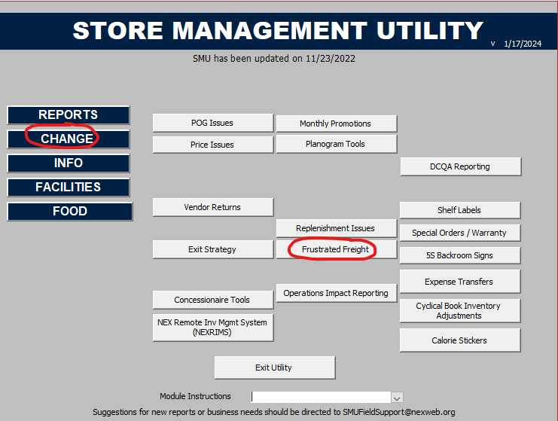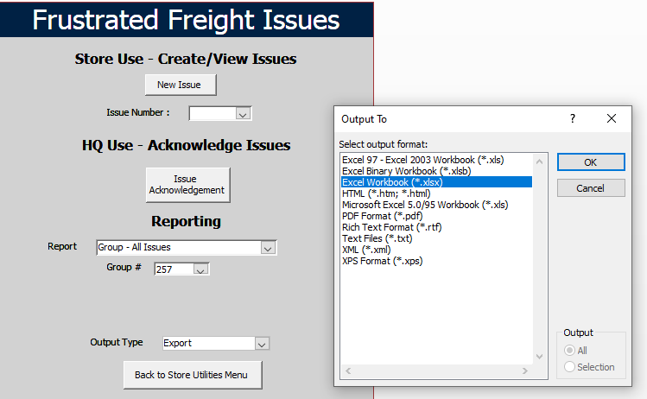
1 to view all issues in group.
Complete inside of SMU via Issue Acknowledgement
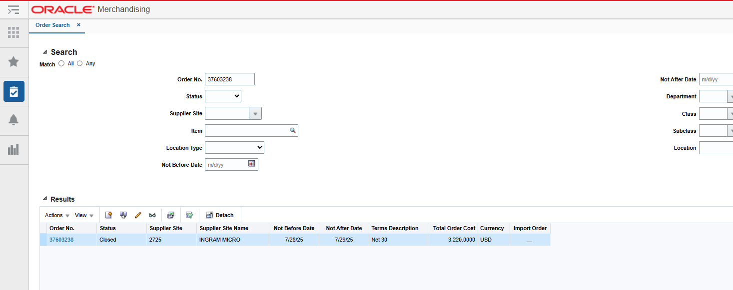
Top of the Document

RA’s & Call Tag
Item(s) need to be returned to vendor.
- Reach out to Vendor POC and ask for RA & a call tag.
- Our Warehouse is going to want call tag issued from Vendor as a part of the RA.
- Vendor will need the following information:
- Item information (NAME, UPC, VPN QTY, Serial number if item was serialized)
- Contact Name
- Company Name
- Address where the product is (# street, city, state, zip)
- Contact phone.
Top of the Document

Item is not on PO.
In some capacity an item arrived at a warehouse and the item is not on the PO
- in V16 under orders- manage orders- search the PO
- in the PO click “details”
- check if the item is listed under the PO.
Item is on PO! Item is not on PO!
Item may not be fully received check ordered qty Cut PO for item allocating item
And check received qty to store.
Item may not exist in system? If so, return to vendor
Example
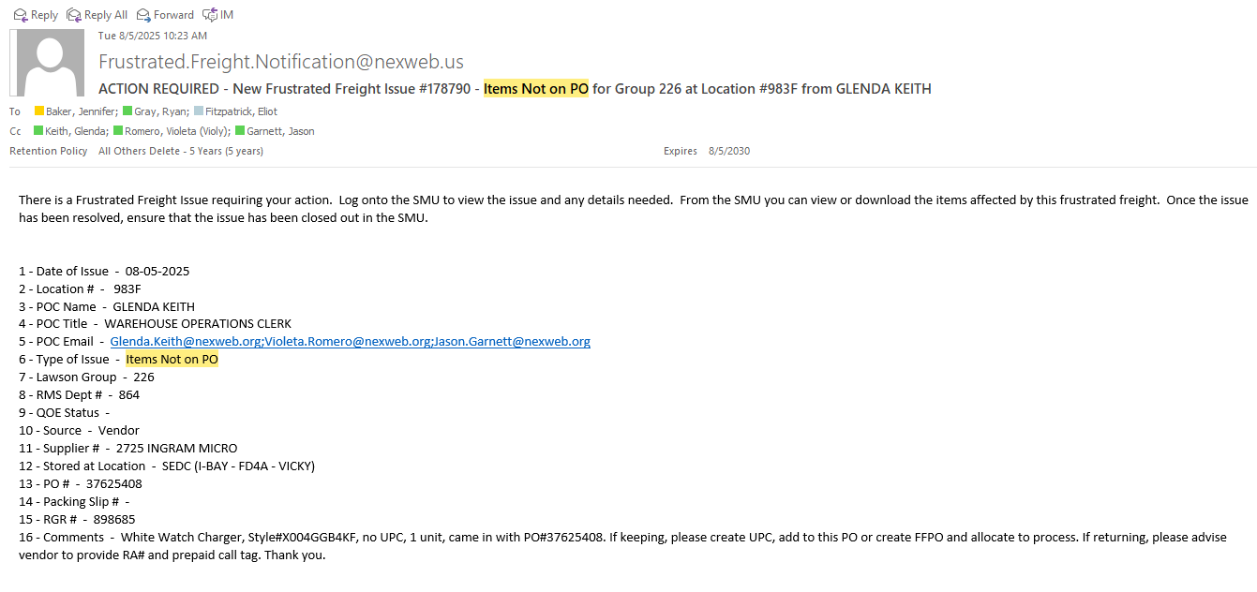
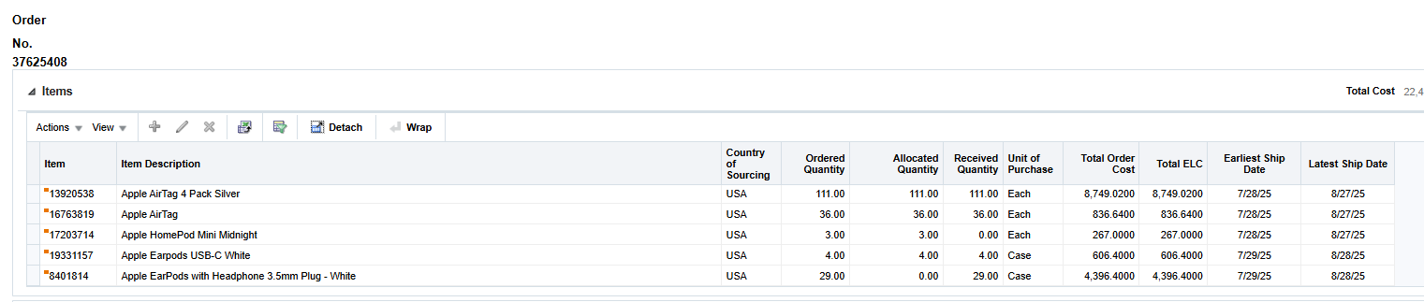
No White Watch Charger on PO and item does not have UPC. VPN did not show in system.
More than likely does not exist. Reached out to vendor for RMA.
Top of the Document

PO not in system
Po not in system?
- Look up PO in v16 more than likely it is expired and needs to be reinstated. And re approved.
- If it cannot be reinstated cut new PO with the items that need to be received and allocate to store.
Example
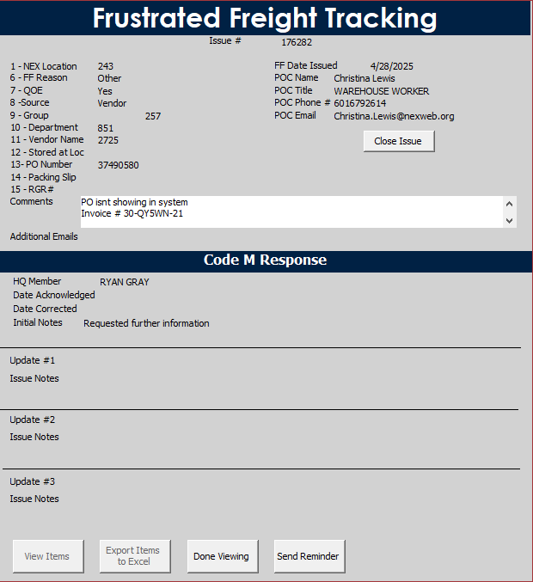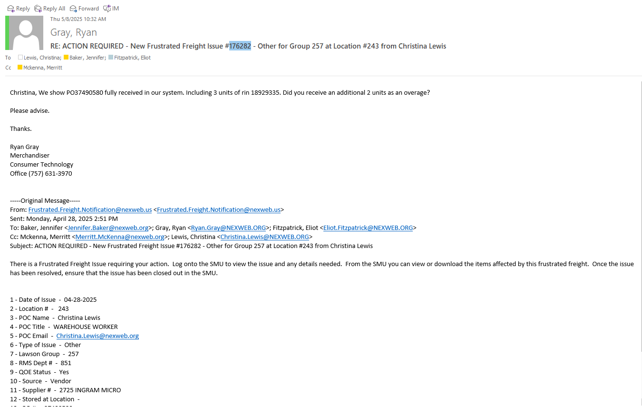
Top of the Document

Over shipment
- Check details under PO.
- If overage was over received under original PO, then an Inventory planner needs to create manual transfer
- If overage was not received into the system create FFPO and allocate to store.
Example
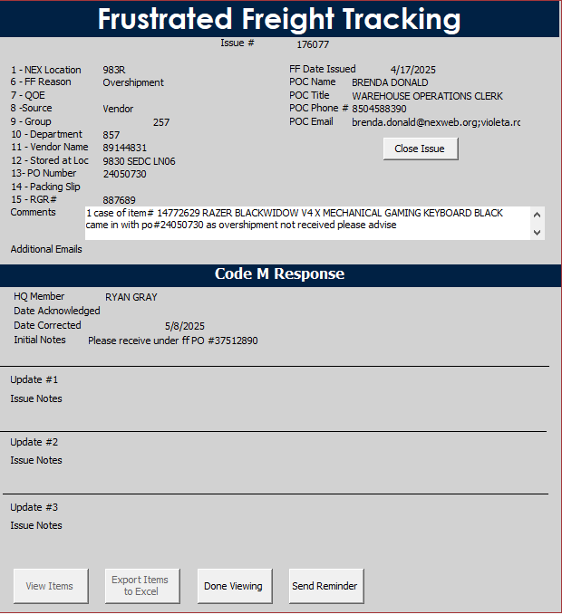
From DC to store for over shipped items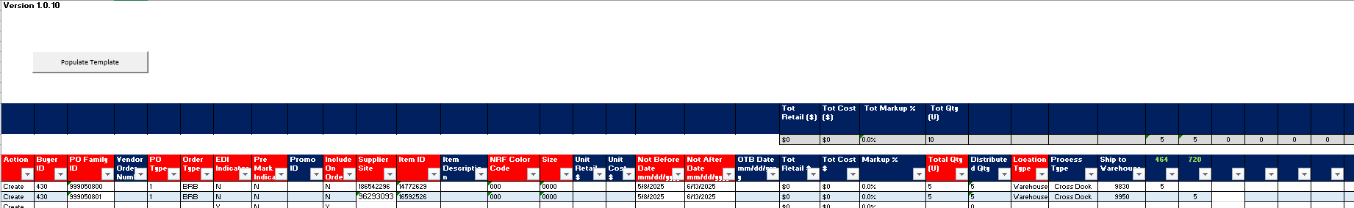
Top of the Document

Item Inductions
OPEN
CHECKER
- When using NRF Color Code 000 please leave the NRF color description blank.
- If Initial Retail and MSRP are the same, please leave MSRP blank.
Download Template
My Template
- Fill out Template.
- Run through Item Induction Template Assistant
- Send to DST datastewardteam@NEXWEB.ORG
- Ask DST to serialize high ticket items.
- Drop in brand folder when finished:
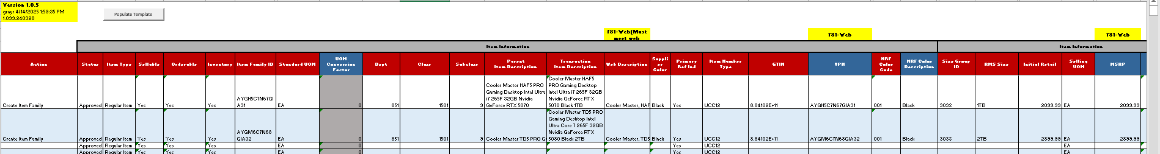
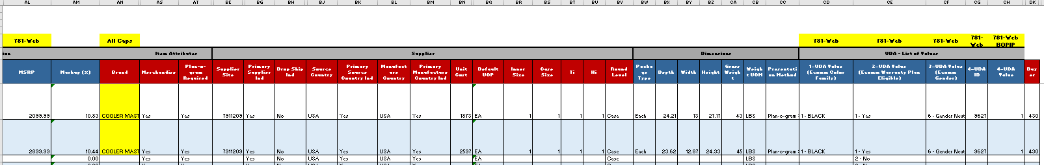
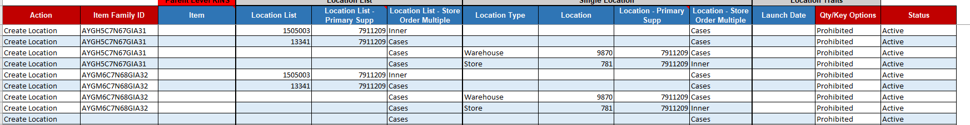

Computer Descriptions
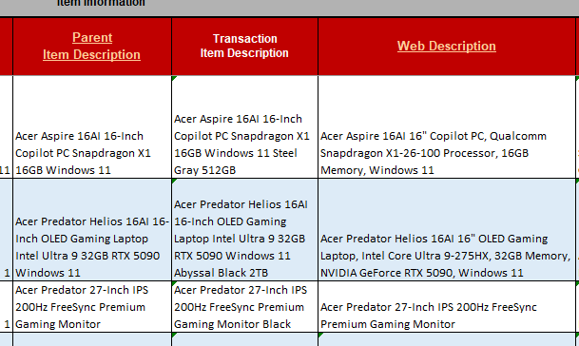

Special Order Items
CC Special order team on induction email
For Special order Apple items Send email to Steve Ross to “Deploy an MNT file for *Item RIN, using *apple care RIN.

Drop ship item inductions & store.
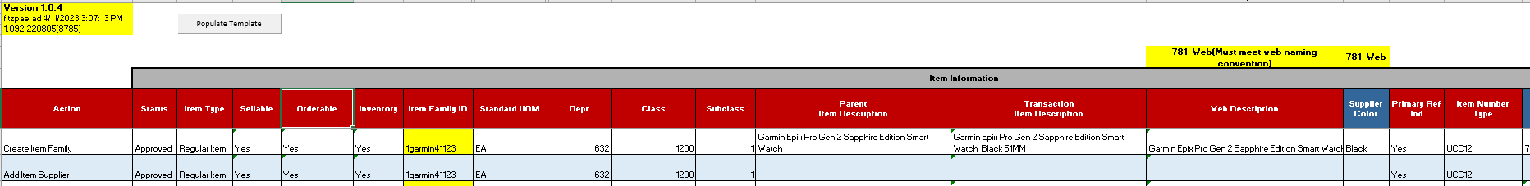
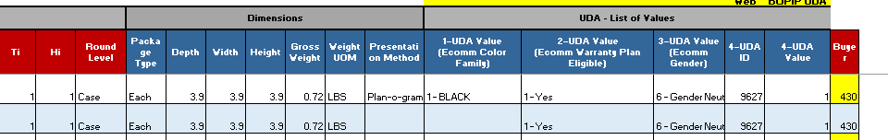

Displays
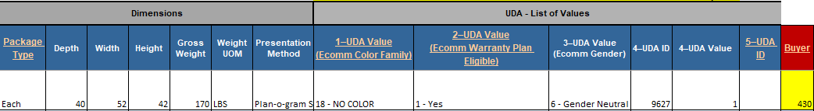

Inner and case pack

Add Supplier
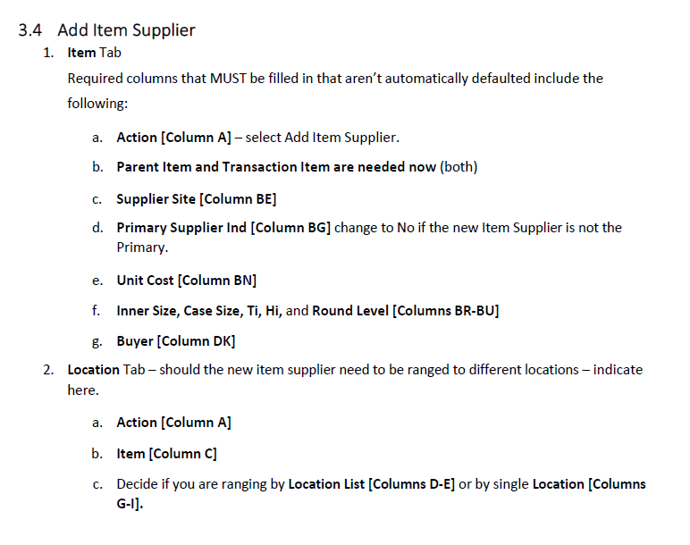

Item List
OPEN
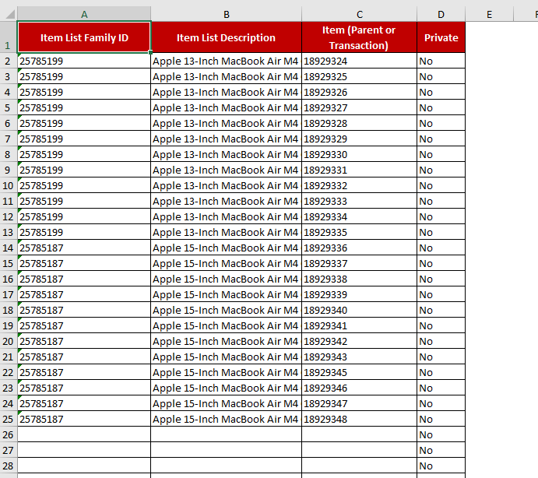
V16 – Foundational Data – Items – Upload Item list from file

Creating an item list manually
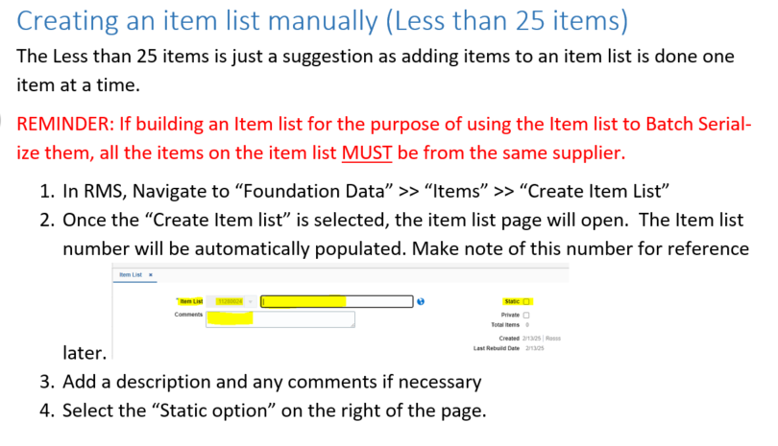
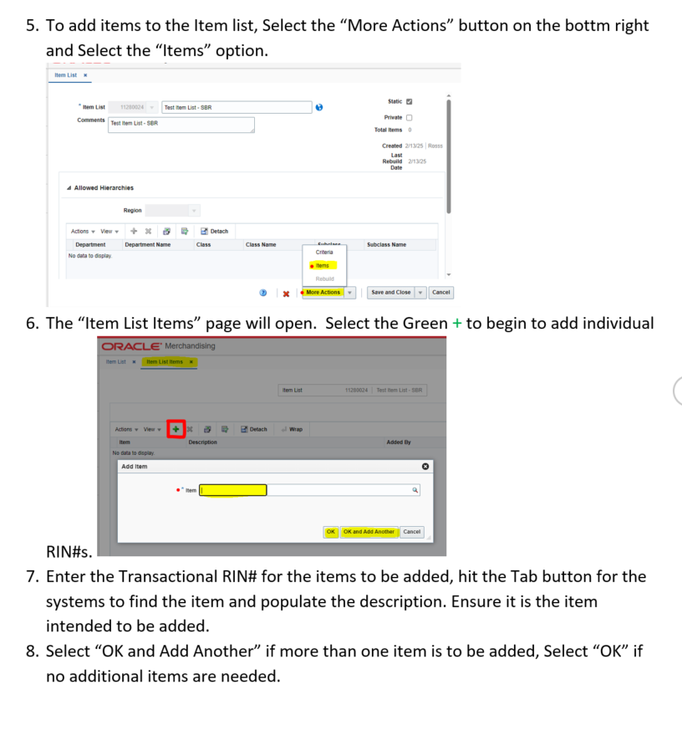
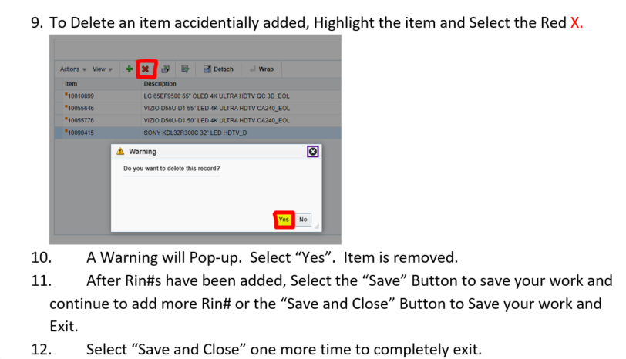

Creating an item list
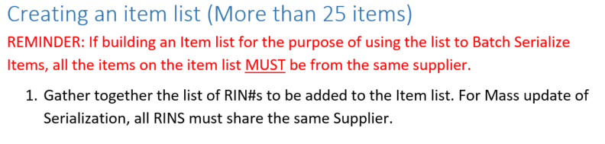
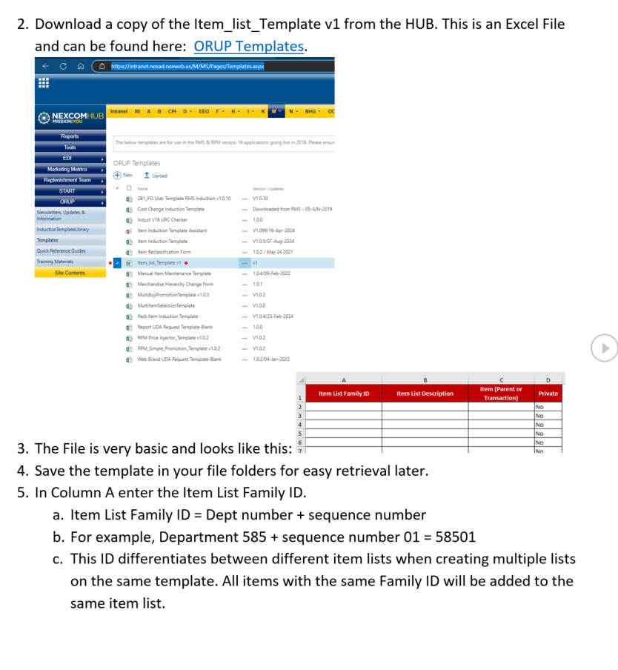
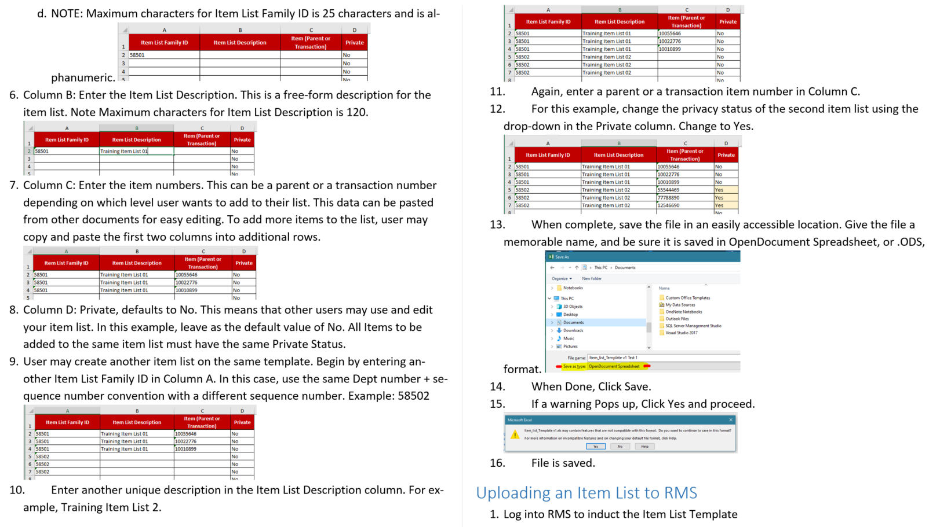
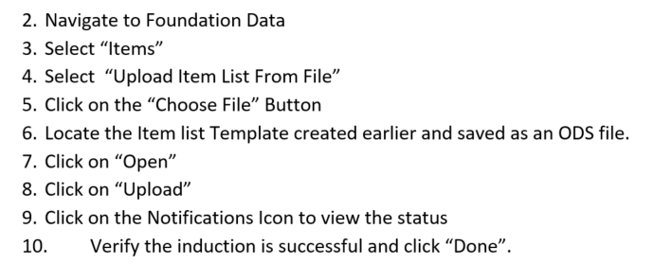
Top of the Document

Item list RMS V10
Instructions for submitting RMS10 item list or location list requests to LoadRunner:
- LoadRunner Template for item and location lists can be found at link:
There are 3 functions that can be completed via LoadRunner, each with a separate tab on the template.
- Item List Build (creating a brand-new item list)
- Edit Item List (adding and/or removing items from an existing item list)
- Loc List Build (creating a brand new location list)

The template also contains example tabs of each function to assist you with completing the required information. Please see below for detailed instructions.
Once template is complete, email to ROADS@NEXWEB.ORG.
Please contact ROADS with any questions regarding the LoadRunner template.

To build a new item list:
- Use the tab labeled ITEM LIST BUILD
- Enter a name for the list in cell B2.
- Enter/paste all RINs to be included on the list starting in cell B4. The item count in row 3 is a formula that will populate automatically.
NOTE- up to 20 item lists can be built using the same form. DO NOT add or delete columns in the template, or edit formulas in column W.
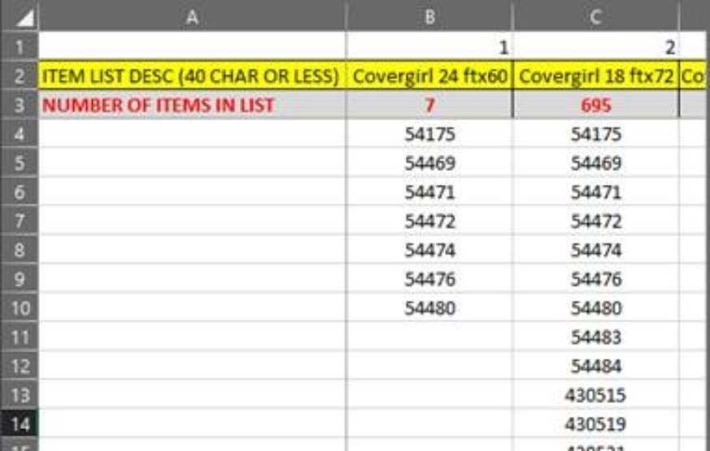

To edit an existing item list:
- Use the tab labeled EDIT ITEM LIST
- Enter the current number of items on the list in cell B2.
- Enter the item list # in cell B3.
- Enter a name for the list in cell B4 (can be existing name or a new name)
- Enter all RINs that should be included on the list going forward (existing and new). DO NOT include RINs that are being removed.
NOTE- up to 25 item lists can be edited using the same form. DO NOT add or delete columns in the template, or edit formulas in column AB.

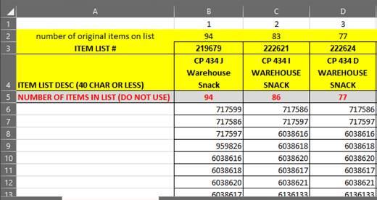

To build a new location list:
- Use the tab labeled LOC LIST BUILD
- Enter a name for the list in cell B2.
- Enter/paste all locations to be included on the list starting in cell B4. The record count in row 3 is a formula that will populate automatically.
NOTE- up to 12 location lists can be built using the same form. DO NOT add or delete columns in the template, or edit formulas in column O.

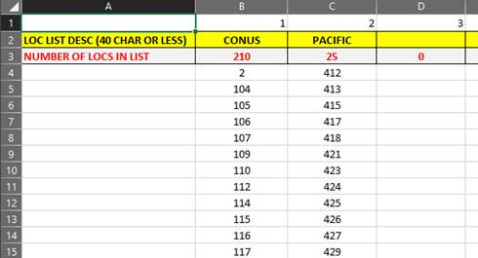
Top of the Document

Item Reclass
OPEN
My Template
Fill out template.
*Must be Parent rins not trans. Has to be done at highest level.
Send to DST
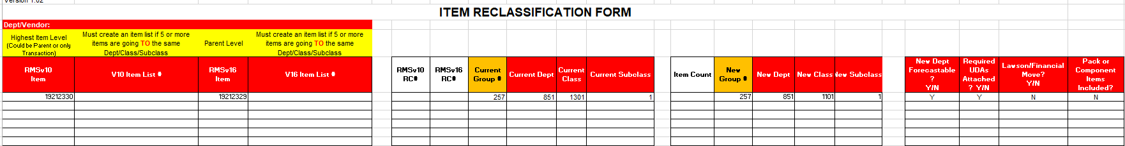
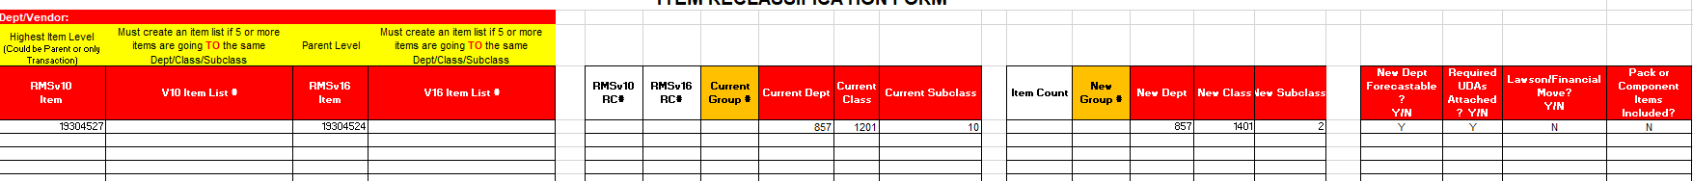
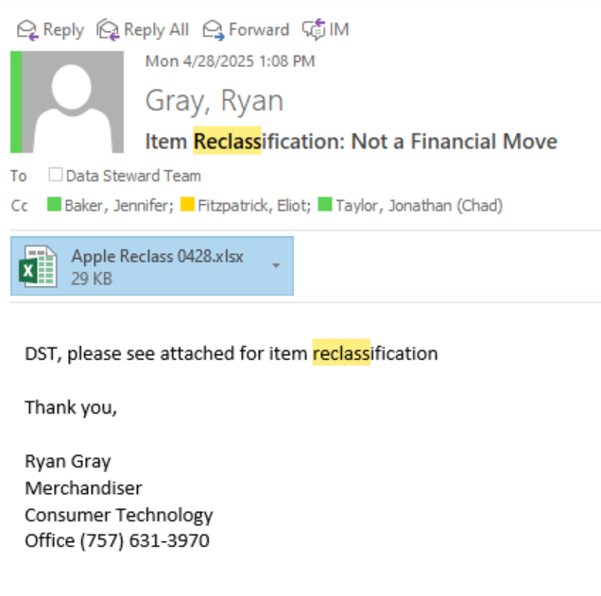
Top of the Document

Mail Package
OPEN
My Template: Store location

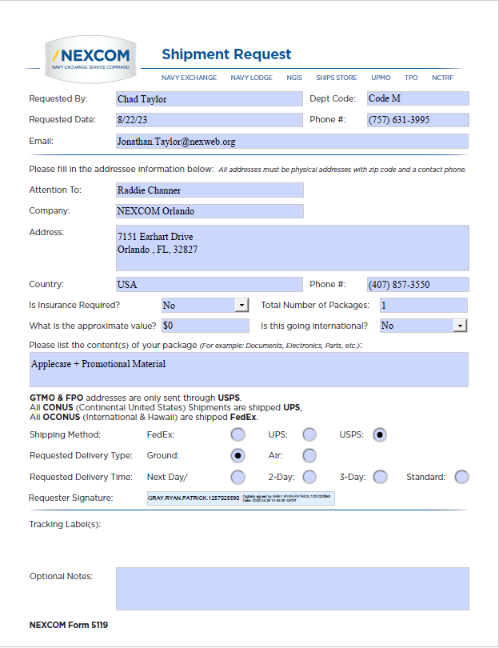

MSA
G:\Code_M\Code_MG1\Group 257\F7 Forecast\1. All Groups MSA
Top of the Document

Promotion Template
Promotion DOF Macro
OPEN
- Template Download: RPM Price Injector_Template
- *When running promotion make sure items are not already running for promotion for the same keyed dates. Promotions cannot be duplicated.
- Buyer Promo Tracker
- Promotions need to end up in “Buyer Promo Tracker.”
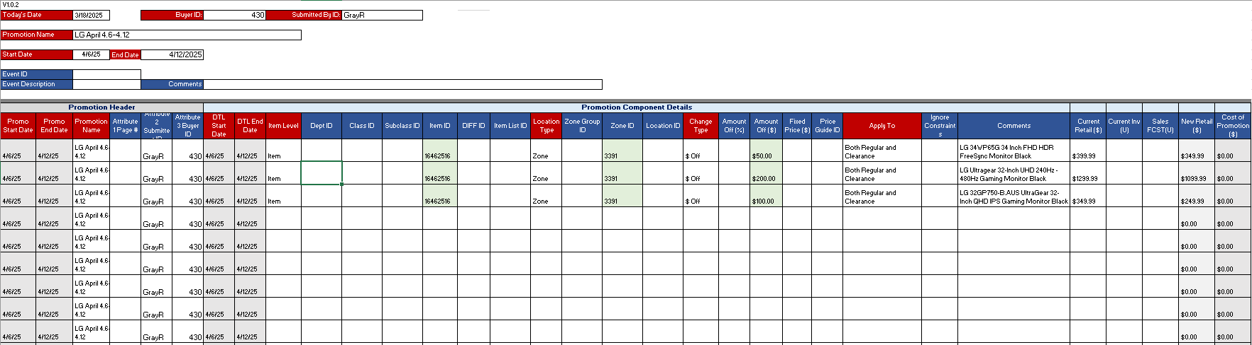
- Fill out the above template and sumbit and then put in tracker OR do below.
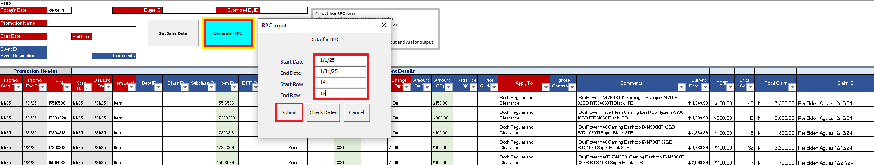
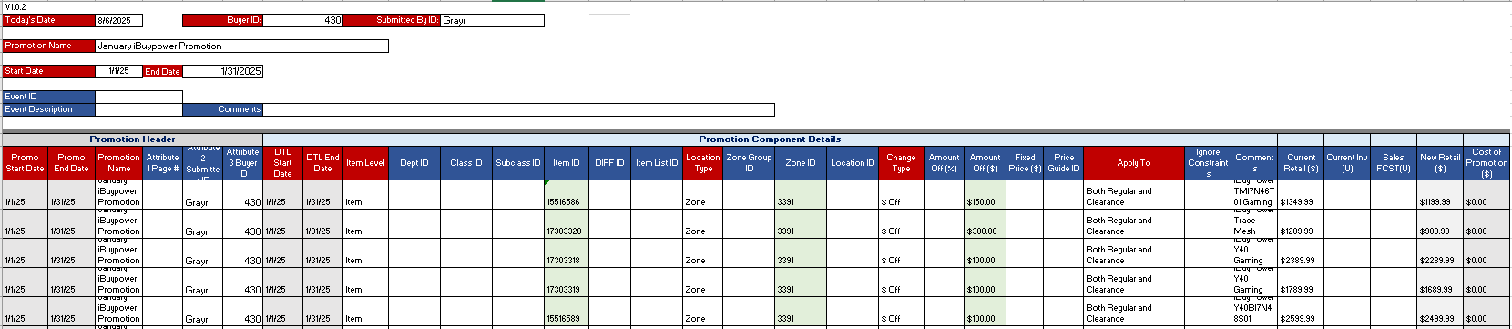
- Email to “Support Tech Action Response Team (START)”
- SUPPORT.TECH.ACTION.RESPONSE.TEAM@nexweb.org
See reference below.
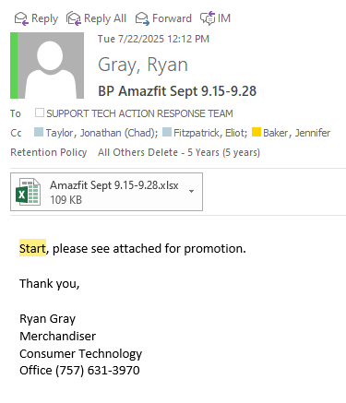
- Promotions with keyed dates within a week of submission need to be sent to DMM for approval rather than sending straight to Support Tech Action Response Team (START)
See reference below.
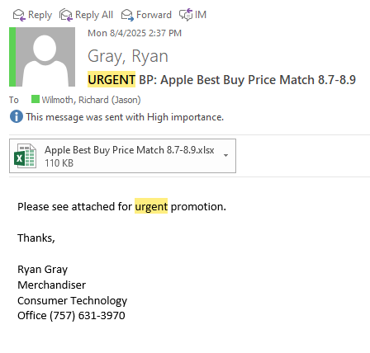
- After Submission file the email sent from the vendor approving the promotion to
Supporting Documentation Folder
- This will be needed for Vendor allowances for the corresponding month.
Top of the Document

PO’s
OPEN
My Template
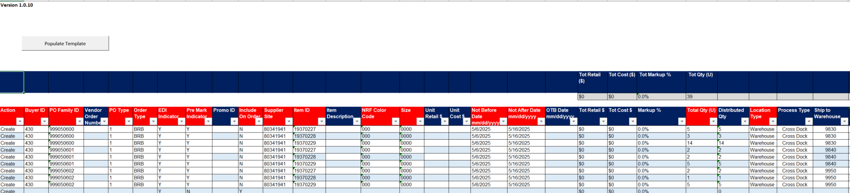
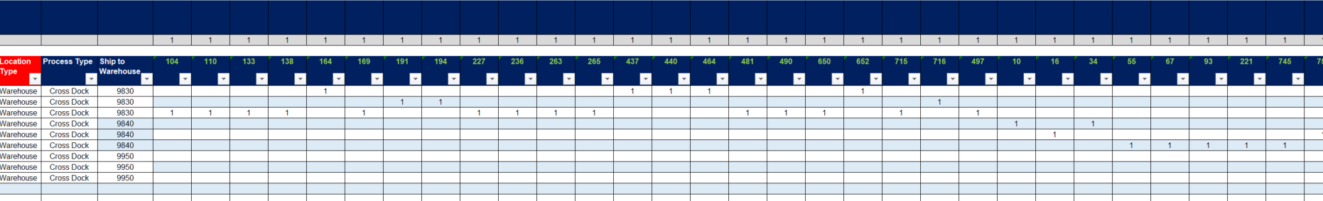Click Populate template save as .xls, save as .ods
Upload ods to V16:
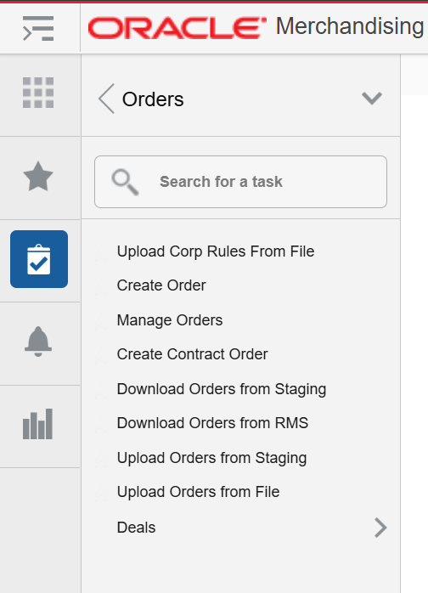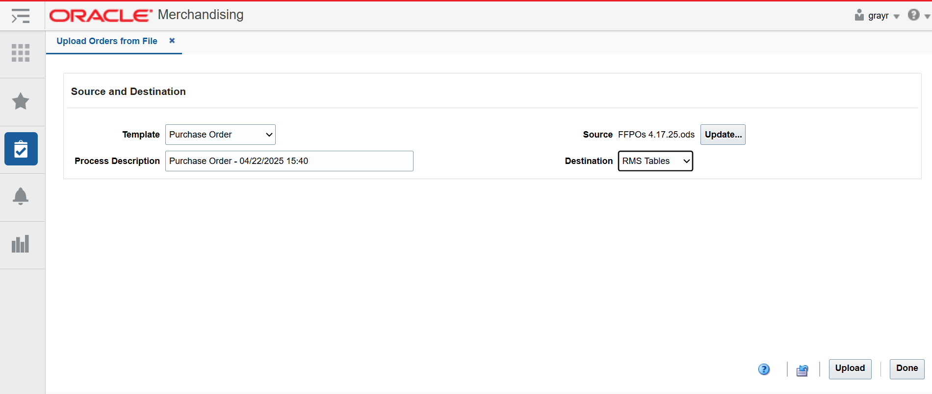
Save copy to: G:\Code_M\Code_MG1\Group 257\PO INDUCTIONS
Send PO numbers to Sarah Hutcheson for approval.

Delete item from PO.
Just delete it. I don’t know.

Top of the Document

Price Change
OPEN
For Price Changes fill out price change template and send to pricing team. (pricing@NEXWEB.ORG)
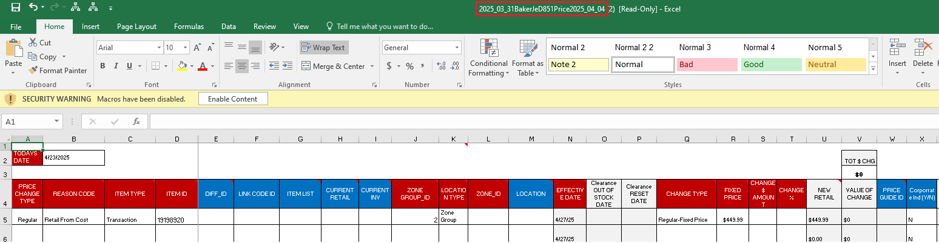

Product Images
Product Images Folder: G:\Code_M\Code_MG1\Group 257\Product Images
Unzip files, if necessary, label folder with product name

Top of the Document

Person of Contact

Quick Reference Guides

Color Codes
OPEN
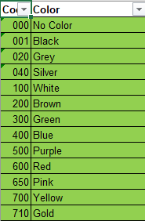

New Vendor Web Brand UDA Request
OPEN
Use Web Brand UDA request template.
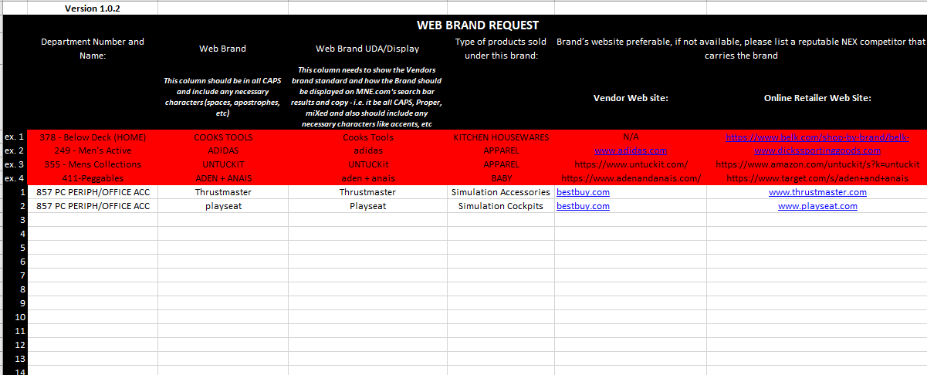
Attach template to email with induction items.
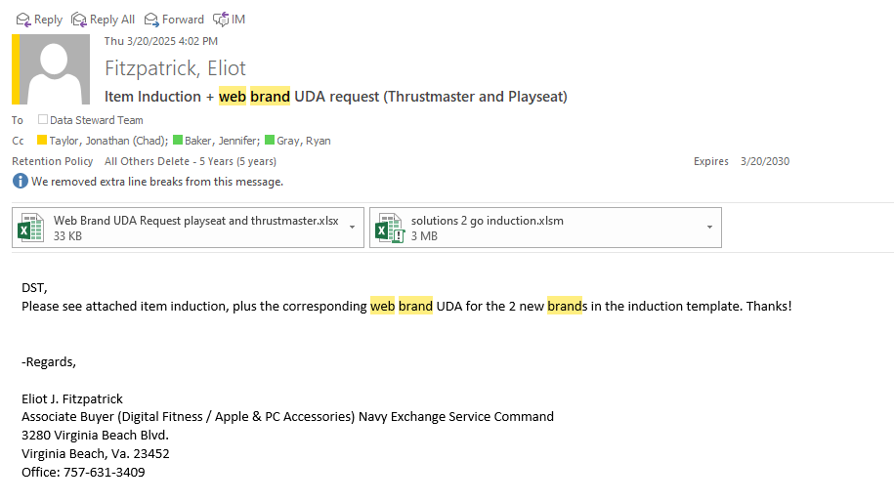

Hardlines Web Naming Conventions
OPEN
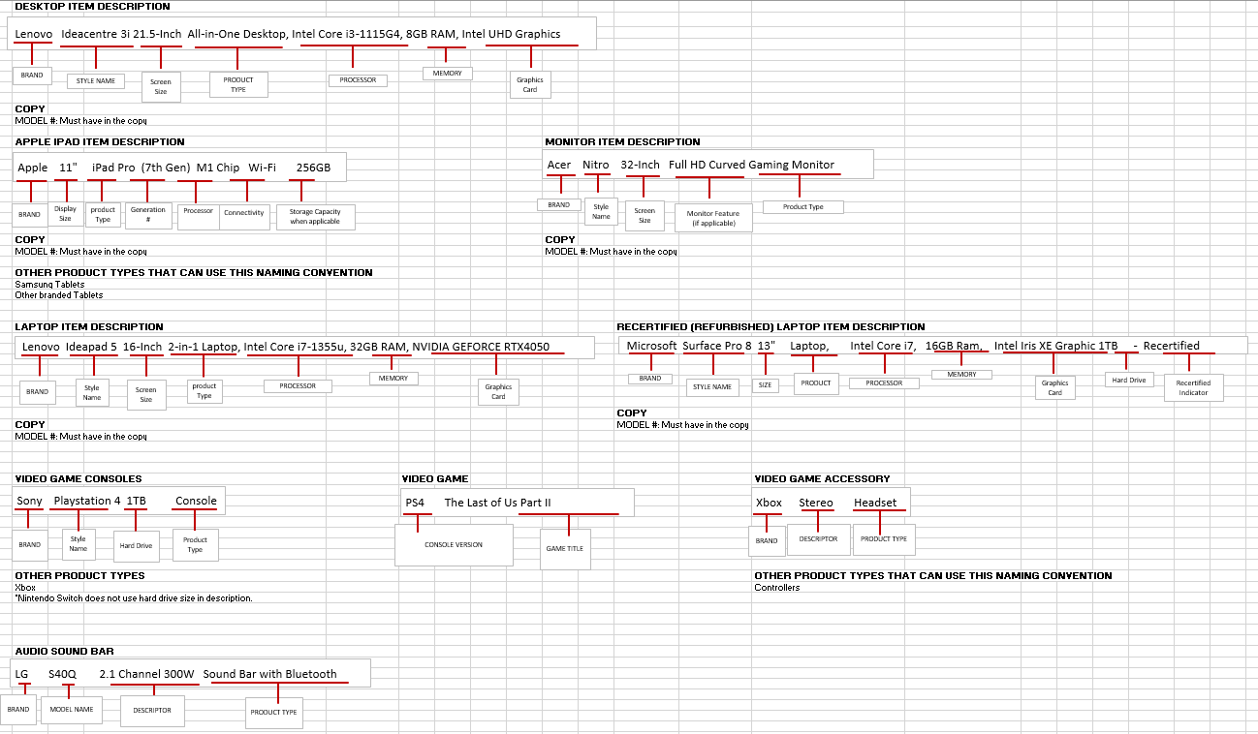

Buyer Numbers
OPEN

Store Locations
OPEN
Color Codes | New Vendor Web Brand Uda Request | Hardlines Web Naming Conventions | Buyer Numbers | Size | Store Locations
OPEN | OPEN | OPEN | OPEN | OPEN | OPEN

Top of the Document

Ranging Items

Serialization

Single Items
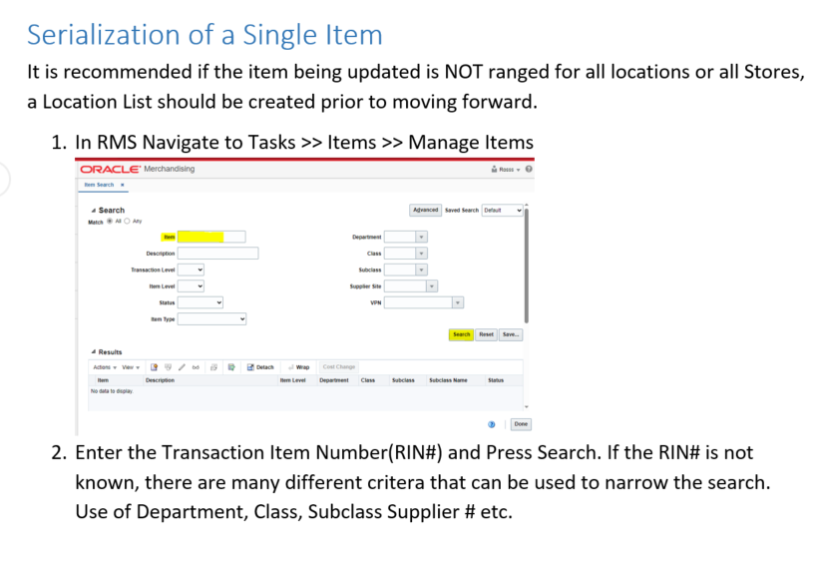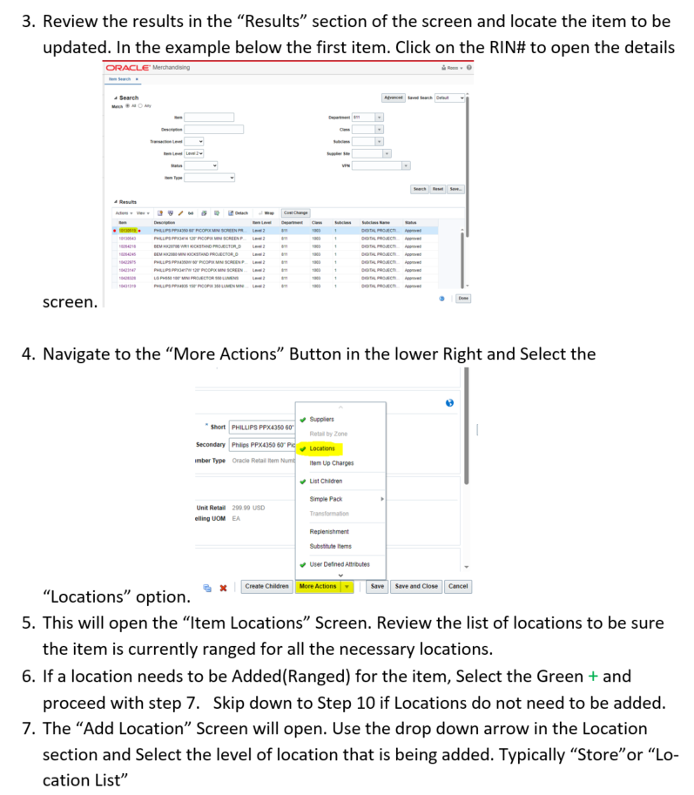

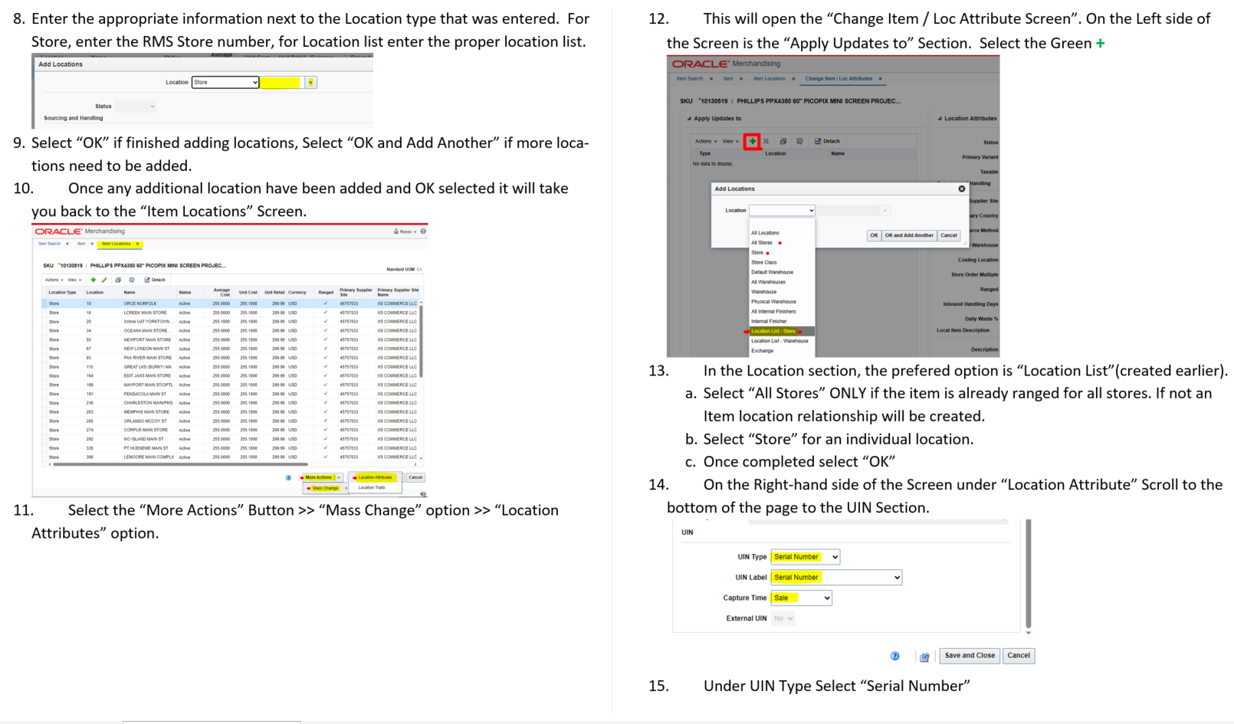
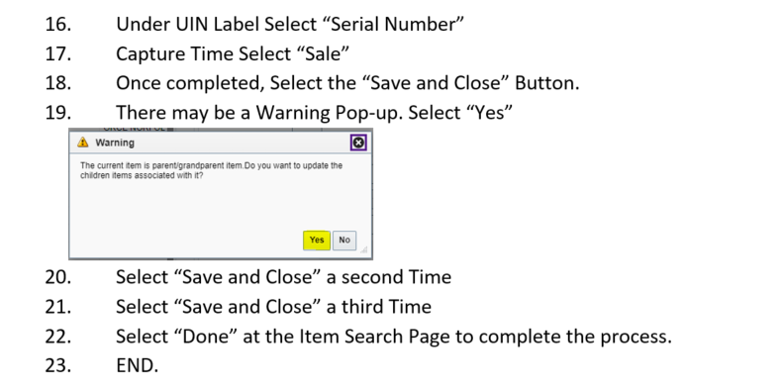

Mass Items
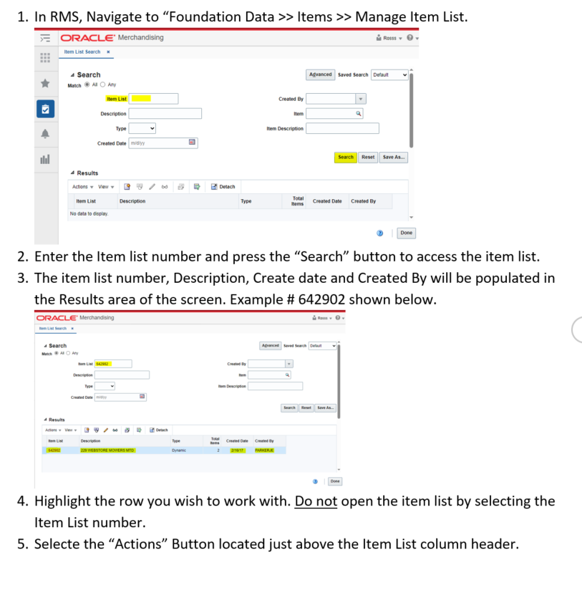
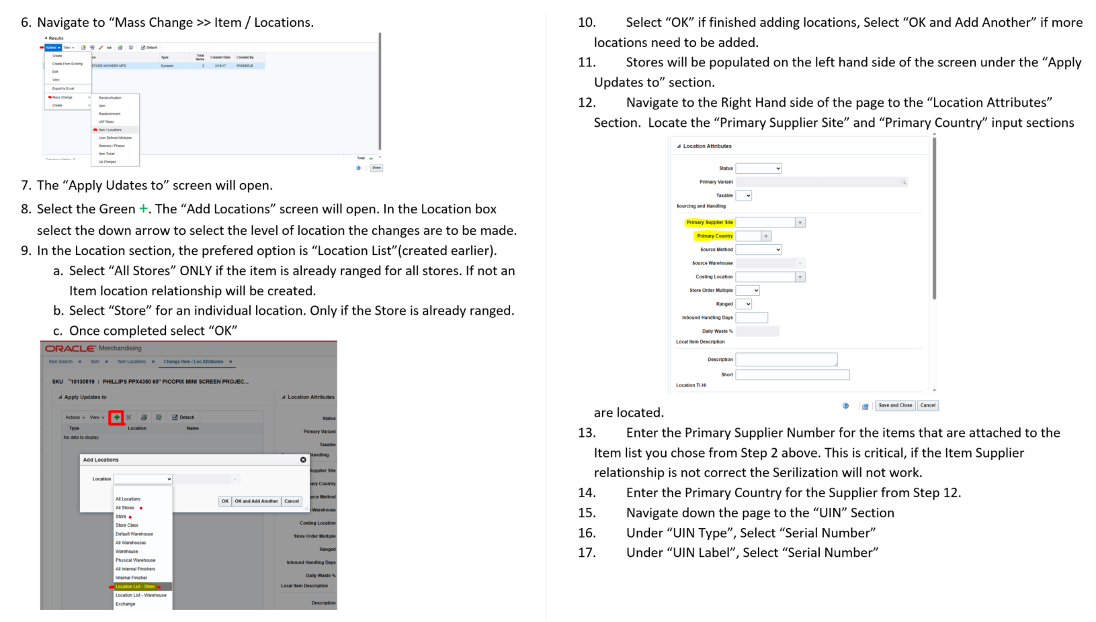
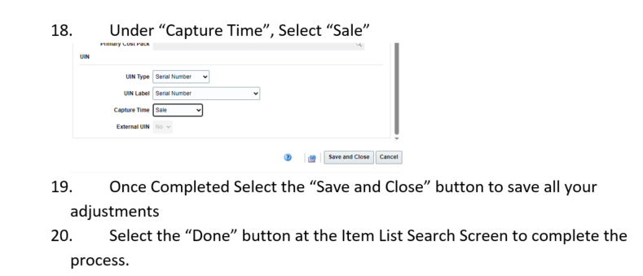

Top of the Document

Store Order Multiple (SOM) Change
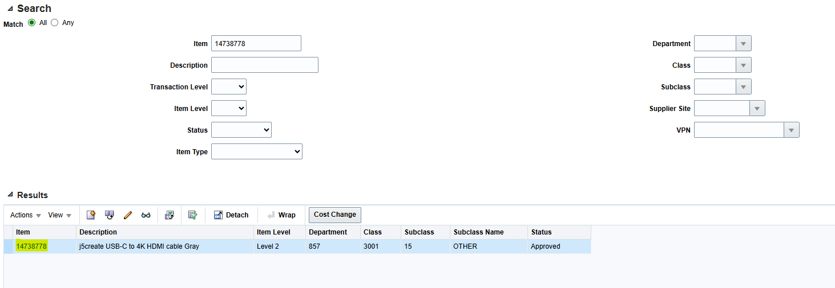
Find and click on item in RMS.
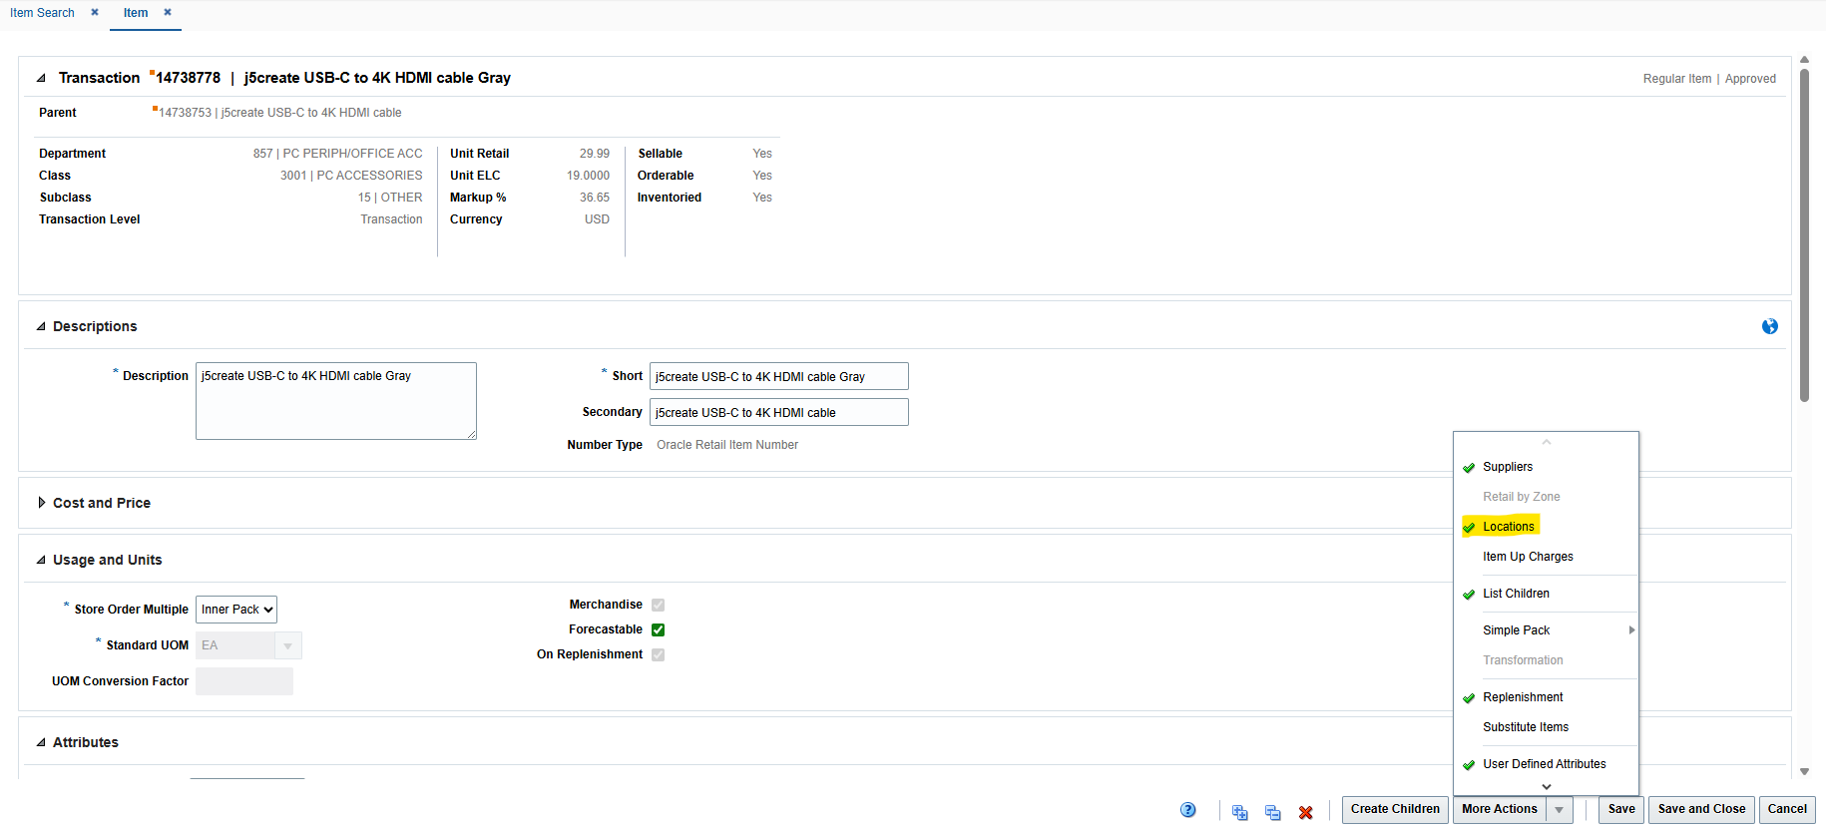
Find more actions and click on locations.
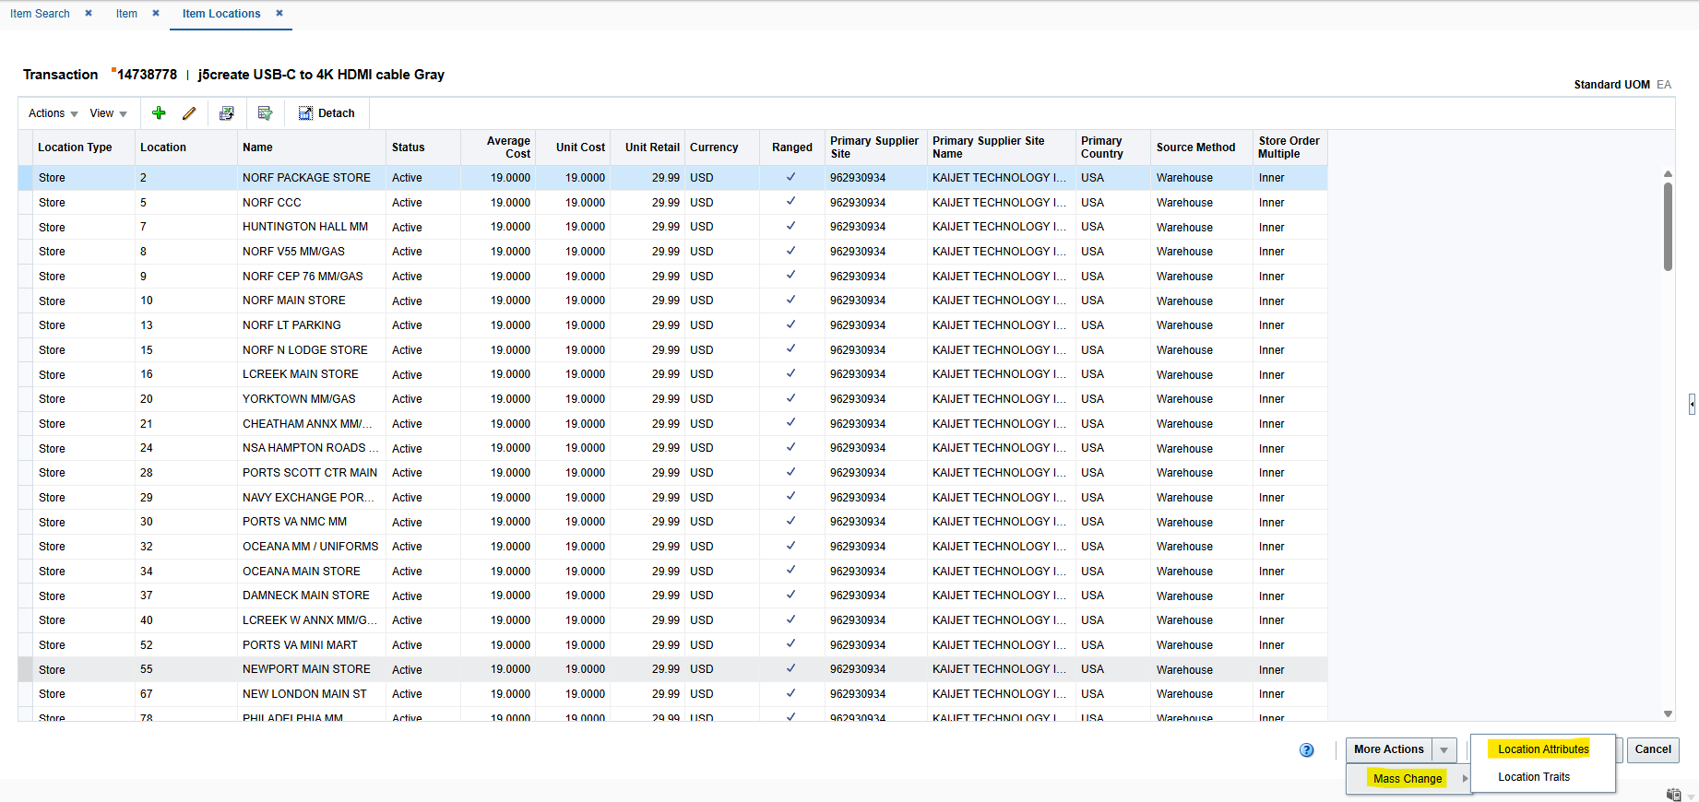
Find more actions again and click on mass change and then location attributes.
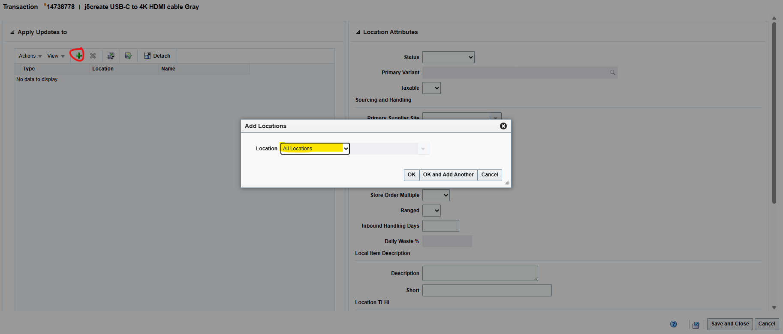
Click “+” and then select “All Locations” or whichever may be applicable. You may just want warehouses. Then click “Ok.”
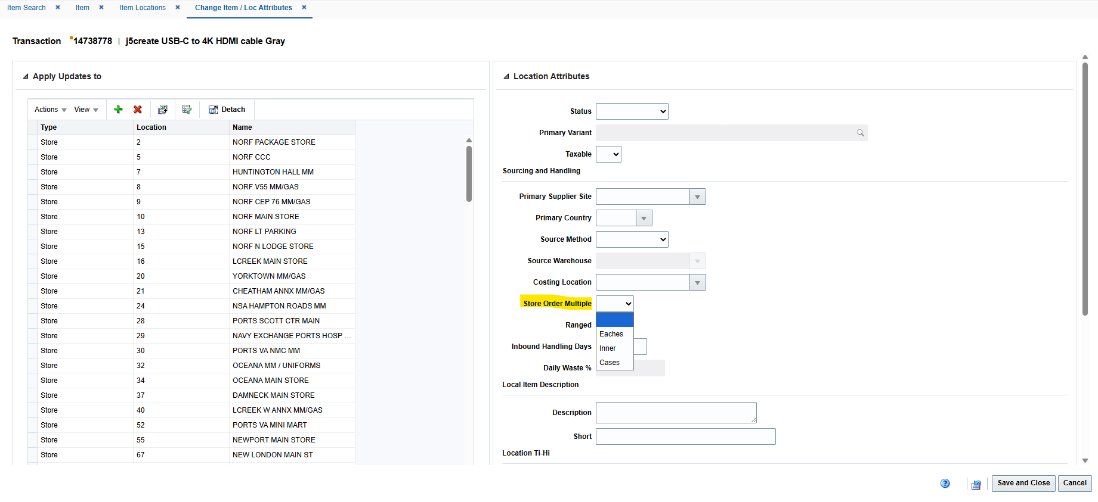
Find “Store Order Multiple” on the right and change to the desired outcome.
Select and save and close.

SQL (Structured Query language)
Select: column1, column2… From: table_name Where condition (Group by) column1, column2 Having condition (Order by ) column1,column2…,
Sample of Simple Select Statement. (SELECT column1, column2, column3 FROM table_name)
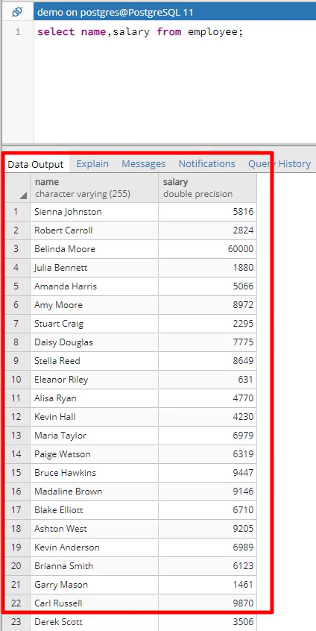
Where clause is used to filter the rows based on certain conditions
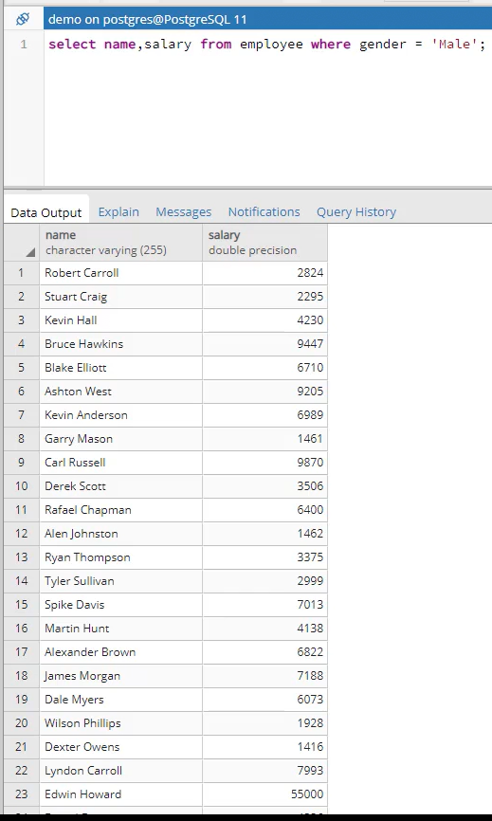
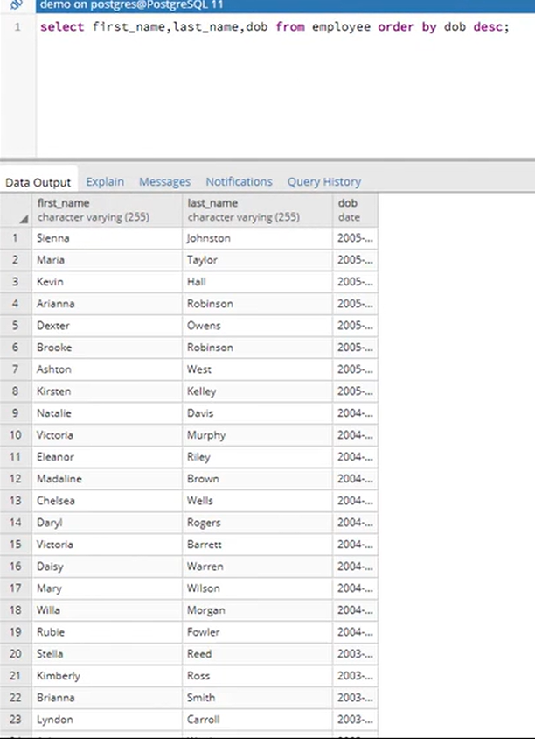

Vendor Allowances
OPEN
G:\Code_M\Code_MG1\Group 257\Chargebacks
VADB: VADB 5445A_User
OPEN RDW QUANITSENSE: https://microstrategy.nexad.nexweb.us/MicroStrategy/asp/Main.aspx
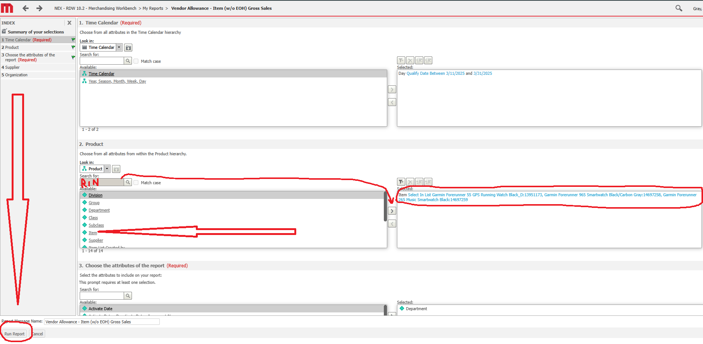
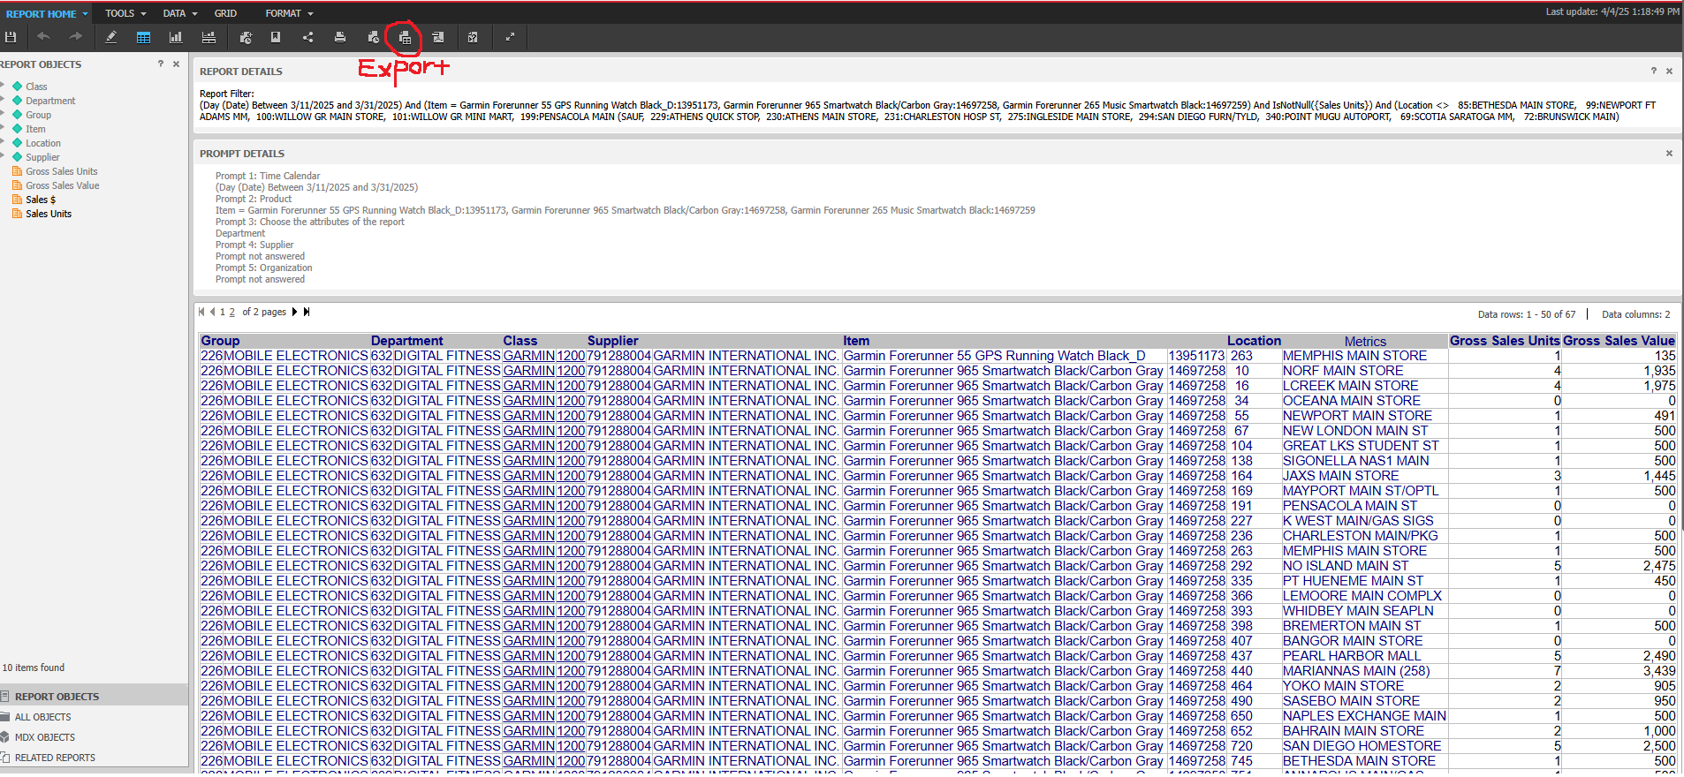
Export to G:\Code_M\Code_MG1\Group 257\Chargebacks\2025 CHARGEBACK FOLDER\VA Reports
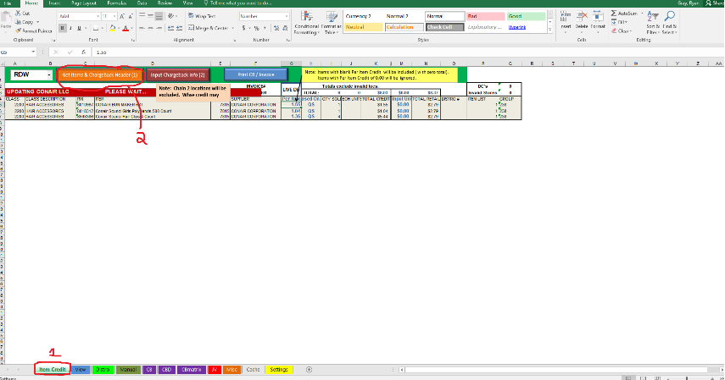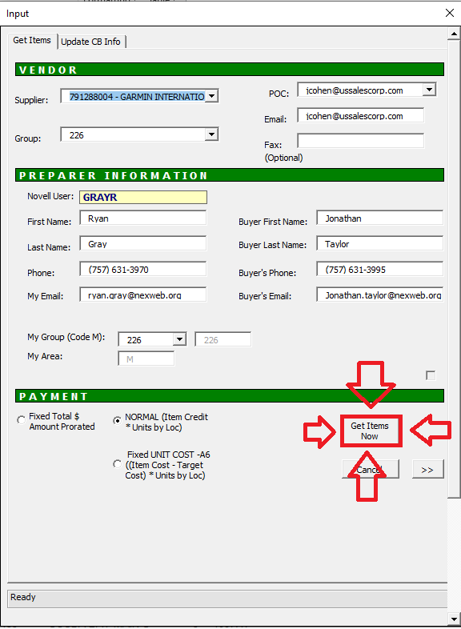
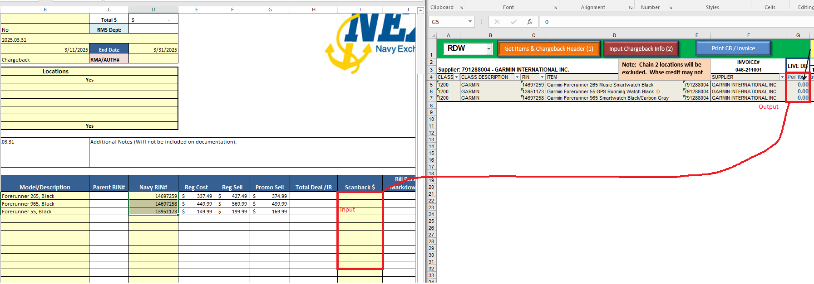
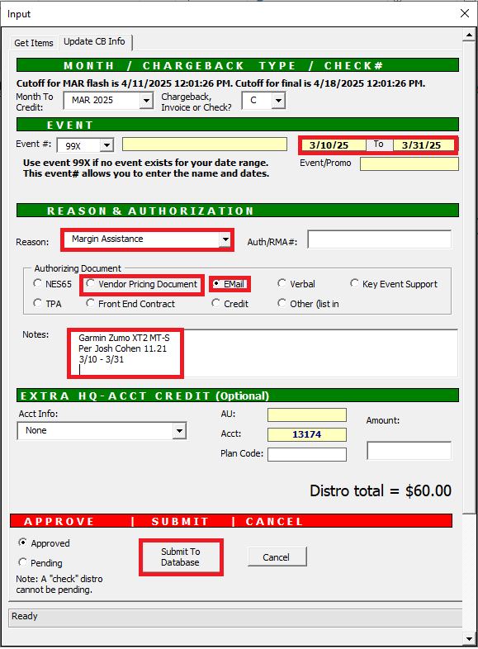

Email Chargeback
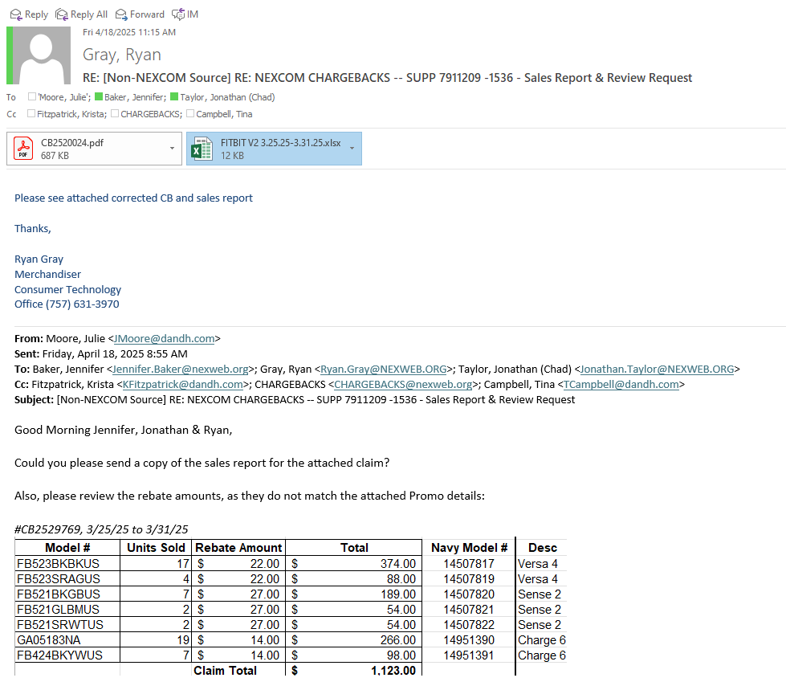
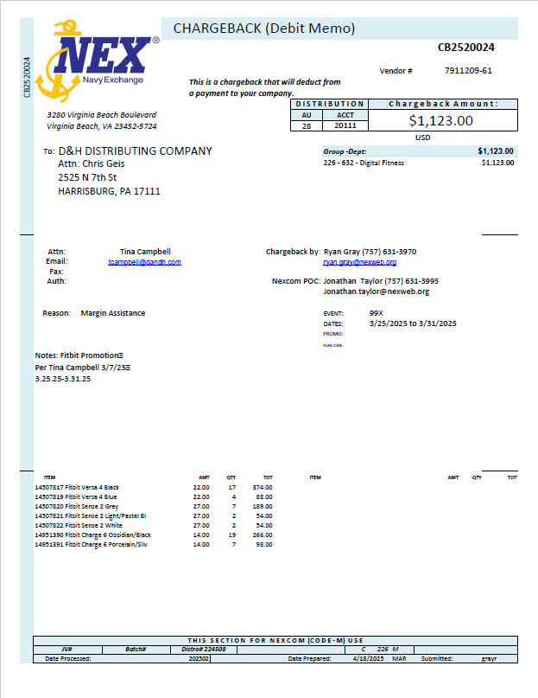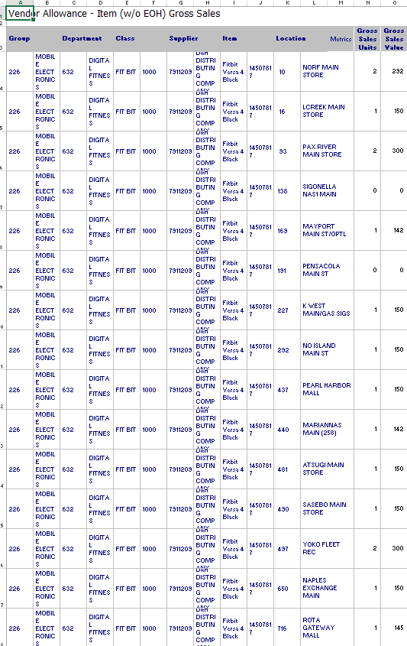

Top of the Document

Report to DMM – Jason
2025 CT Chargeback Tracker
Open CT Chargeback Tracker.
Then open VADB – View – Select period – Update View
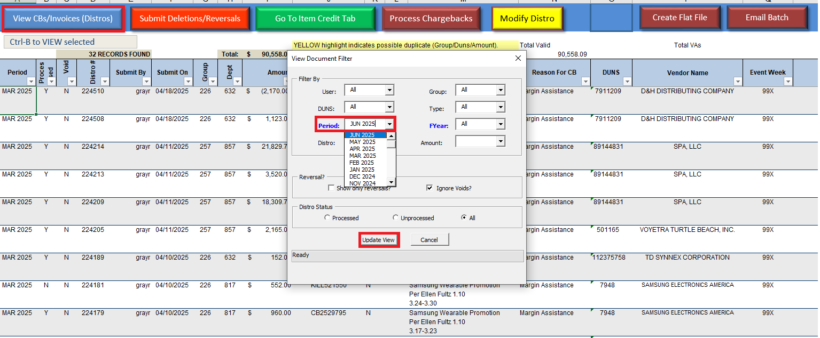
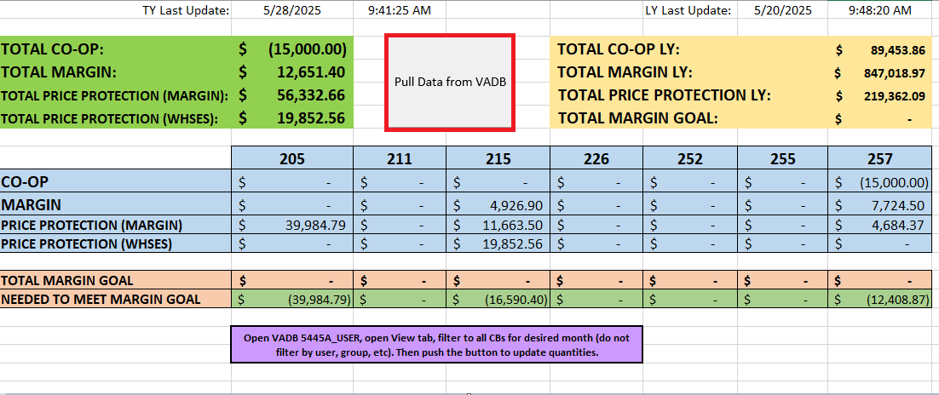
Pull data from VADB.
Screenshot Data and email to DMM.

VADB POC LIST
Here
Top of the Document

Website URL
RMS v16
Item and PO maintenance
https://rms.nexweb.us/Rms/faces/RmsHome

RMSv10
Usually for FFs (syncs with store systems like SIM)
http://hqibm31.nexweb.us:8080/workbench/index.jsp
shortcut on desktop!

MicroStrategy (RDW and Quantisense)
Reporting for sales, inventory, etc.
https://microstrategy.nexad.nexweb.us/MicroStrategy/asp/Main.aspx

Workfront
Ad proofs & Change Forms
https://experience.adobe.com/#/@nexcom1/so:nexcom-Production/workfront/home

NEXCOM Hub
NEXCOM info
https://intranet.nexad.nexweb.us/Pages/default.aspx

SPS
https://commerce.spscommerce.com/home/apps/
Ingram Micro
https://usa.ingrammicro.com/cep/app/my/return/returnslist

Top of the Document

Who can help?
Link
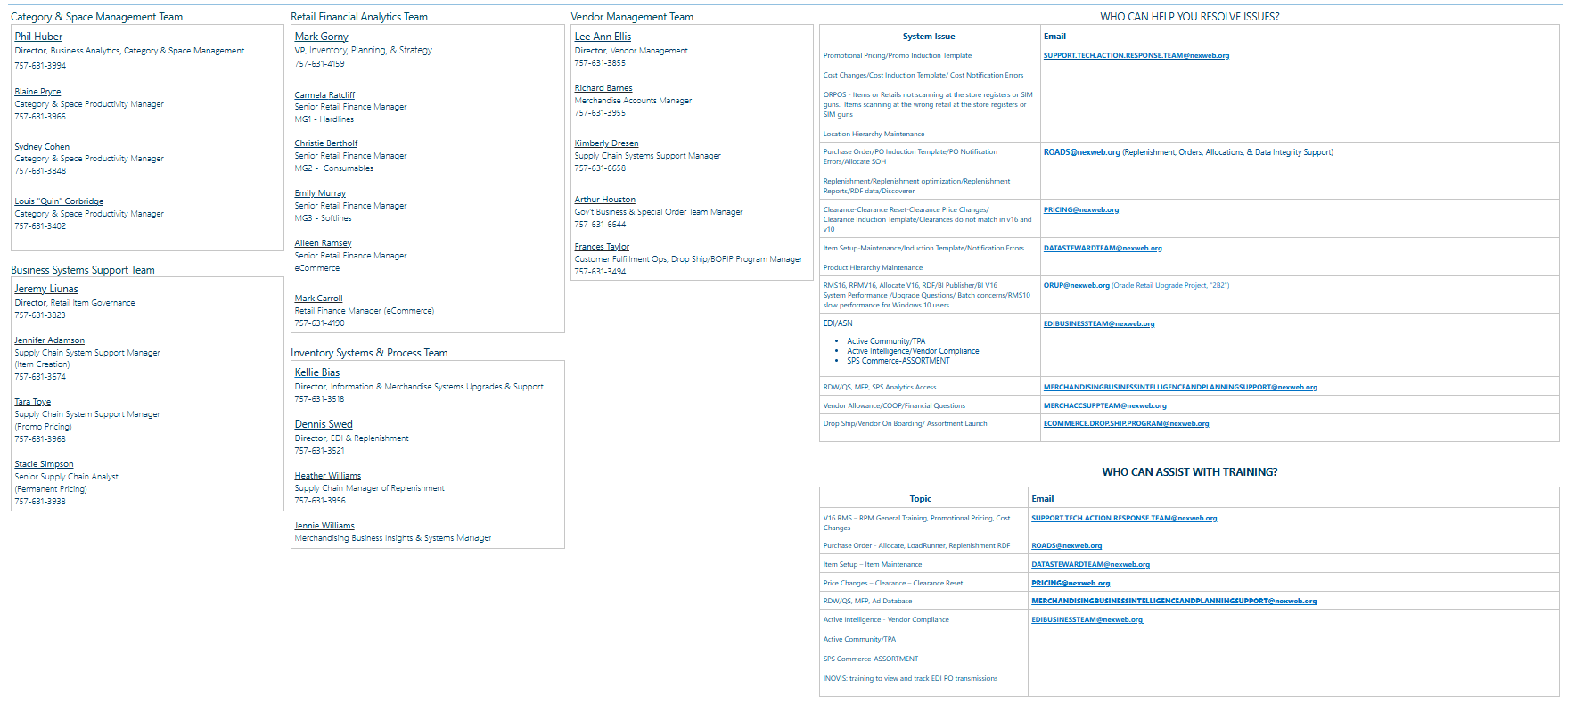

Top of the Document

Consumer Tech Merchandiser Specific

AD Tracker
OPEN
- Ad Tracker Location
- Track Items being advertised on Ad Database on excel spreadsheet.
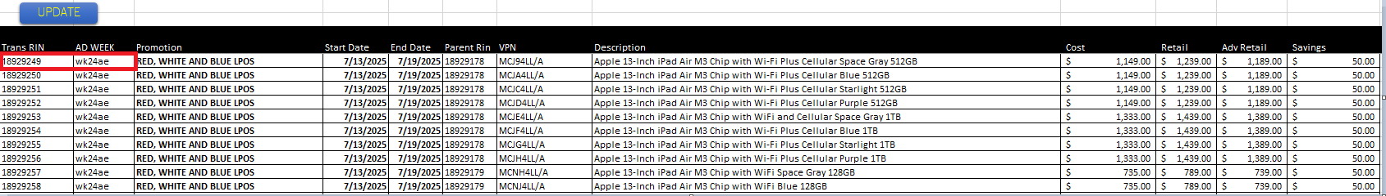
- Fill in rin and week.
- Week should auto fill.
- If not copy formula down.
- Rin information should should update after Ctrl+Shift+U.
Top of the Document

Apple PO’s

COPY and paste as values top portion.
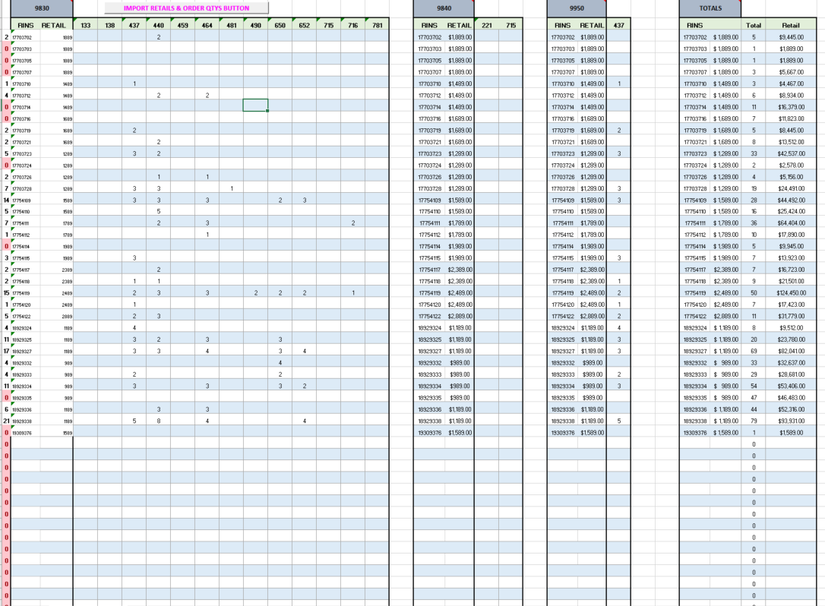
Remove blank rows below.
Delete red totals columns. They are zero and not needed.
In 9830 delete 437 & 715
Redo totals formula (left to right)
Delete zeros on top portion.
Find and replace blanks in po induction and put x in blank columns and rows.
Reverse finds all “x’s and replace with blanks.
Disto qnty messes up so copy data back in
Fix location quantity (Gray up top) slide formula across.

Po update change date to current.
Click more actions- inventory management.
Level to blank save save save.
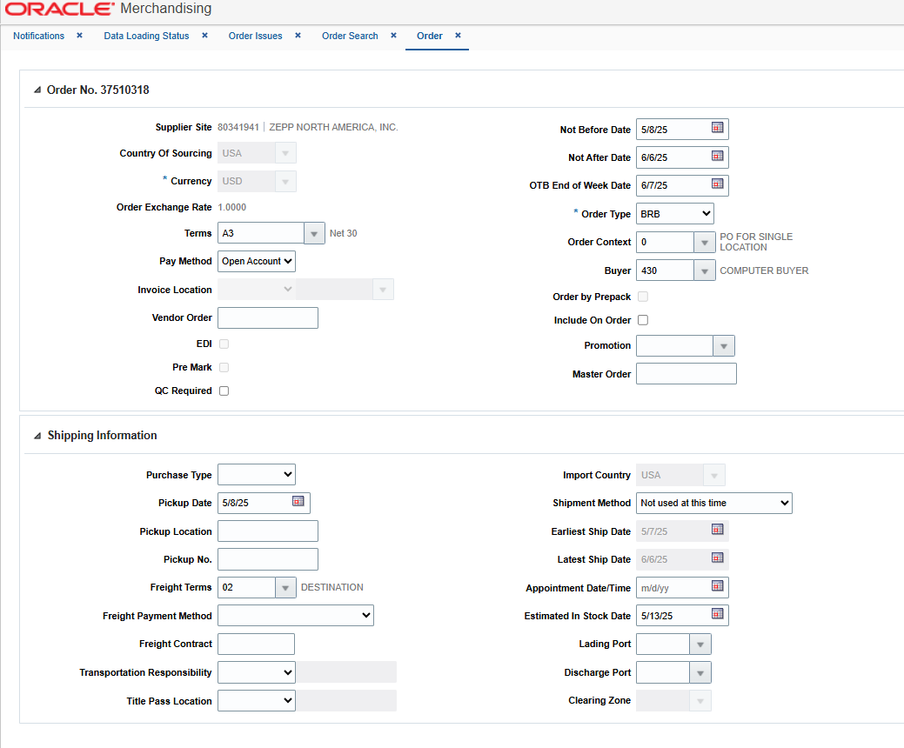

Top of the Document

Apple – Best Buy Price Match
OPEN
Apple Best Buy Price Tracker: G:\Code_M\Code_MG1\CT Fact Tags\5. Apple Sale RPC
*Add sheet – promotions run every Thursday through Saturday of each week.
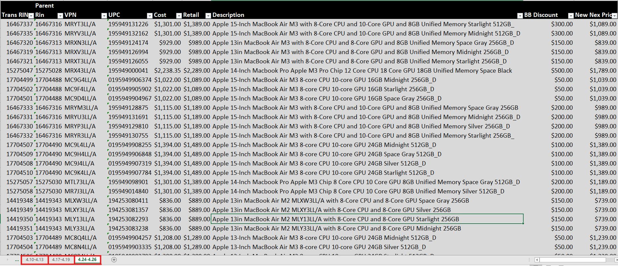
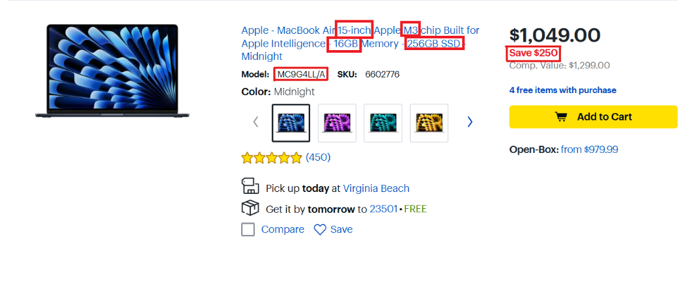
Apple MSA: G:\Code_M\Code_MG1\Group 257\F7 Forecast\1. All Groups MSA
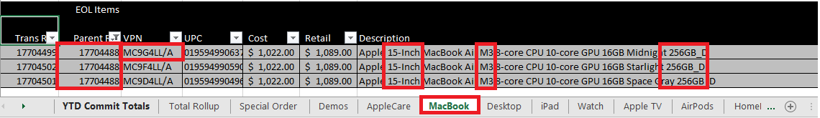
- Copy and paste all items into tracker.
- Verify all parent items are added.
- Remove duplicates after all discounts have been added if needed.
When Macbooks, iPads, Apple Watches, Airpods and Beats discounts are added to the tracker run all items for promotion. Send to DMM for urgent promotion.
Top of the Document

Hardlines Buyer Promo Report
Hardlines Report Macro
Data Cleanup
Remove Column T Faster.
Report from START: G:\Code_M\Code_MG1\BUYER PROMO REPORTS
Sheet 1 Portion
- Save to Desktop folder (Copies)
- Delete Columns A&B&I
- Select Column D – Cut Column –Move to A-
- Select Column D – Data- text to columns – next – next - finish.
- (Select column D) Conditional Formatting->Highlight Cell Rules->Duplicate Values
- Filter Drop down on column D, Filter by Color
- Remove Duplicate Items

Sheet 2 Start
- Rin Inspect all items left.
- Select *Use Item/Loc Query
- Add Sheet
- On new sheet, Delete Columns, B, D, F-I, K-N, Q, U-Z, AB-AE
- Insert three new rows A-C.
- From Last week’s Hardlines weekly Buyer Report copy B1-B2 to M2. Paste to b1 of new B row.
- From Last week’s Hardlines weekly Buyer Report sheet one. Copy column R&S. paste in same place on this week.
- A2 row -> Data -> Filter -> Filter
- In the date(s) column b&c. Home->Date->short date
- Text to columns column E

VLookUp Portion
- For Column B (Start Date), Select B3. Enter =Vlookup(Rin E3,’Sheet1’!A:C,2,False) Copy Formula all the way down
- For Column C (End Date), Select C3. Enter =vlookup(Rin, E3, ‘Sheet 1’!A:C,3,False) Copy Formula all the way down
- From last week’s Weekly Buyer Report (Sheet 1, All the way off to the right) Copy the departments and department descriptor. Paste into Sheet 1 of new report off to the right.
- For Column I (Department) select I3. Enter =vlookup(Dept H3,’Sheet 1’!R:S,2,False) Copy formula all the way down.
- =vlookup reg price, sale price

Filter Portion
- Select Savings column filter, deselect all and select blanks.
- Delete all of them by selecting the last row in table, Scroll all the way to the top row. Shift+click first row. Delete row.
- Filter Savings Low to High and delete all negative rows.
- Filter Reg. Price to pennies and delete all pennies priced items.
- Add SOH as of date to N2.
- *Select entire table (minus the title) Copy and paste table just as values
- With entire table still selected ctrl+t to create table.
Slicer Portion
- Insert->slicer-> Filter to Store & Department
- Move department Slicer to top left.
- Right click -> Size & Properties
- Position and layout Dropdown: Button Height: 0.2.”
- Adjust slicer length to show no scrollbar.
- Move Store Slicer below Department Slicer
- Change Columns to3 Button height to 0.2.”

Print Portion
- Hide Column I
- Make each column fit to text properly.
- Page layout->Print area
- Select only the table (Do not include slicers)
- Print Setup: Landscape, Fit all columns on page, Narrow Margins
Save to: \\nexad.nexweb.us\HQ\Code_All\Code_M\Code_MG1\Hardlines Buyer Promos\2026 Hardlines Buyer Promos
Upload to Hub: https://intranet.nexad.nexweb.us/M/MG1/Electronics%20Promos/Forms/AllItems.aspx
Send to: communication.requests@NEXWEB.ORG
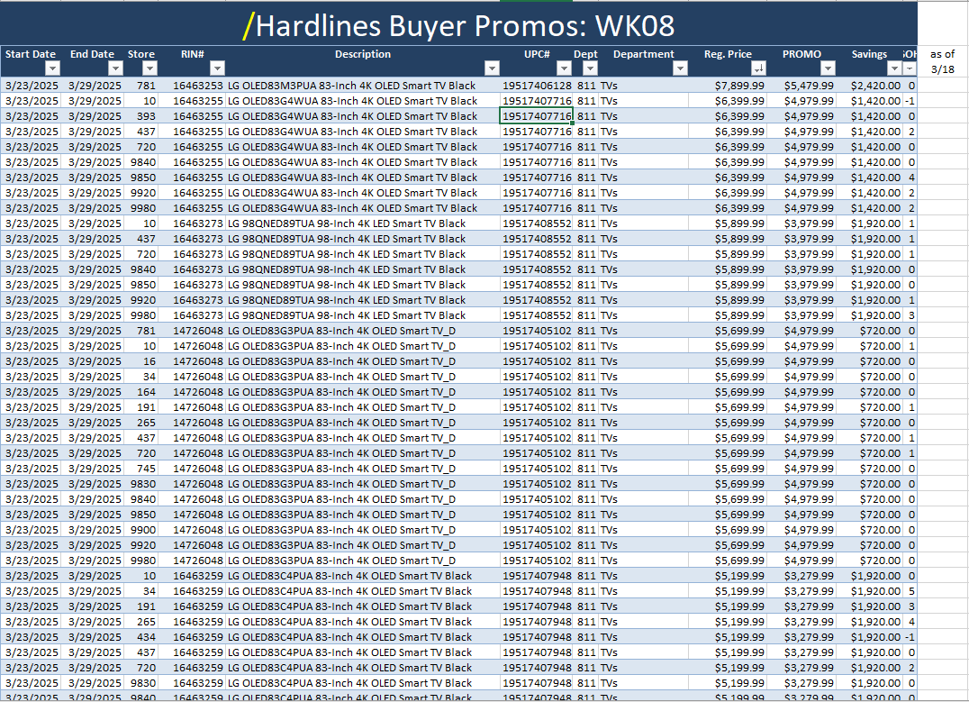
Top of the Document

Promotional Fact Tags
- From “Buyer Promotion Report” Copy items
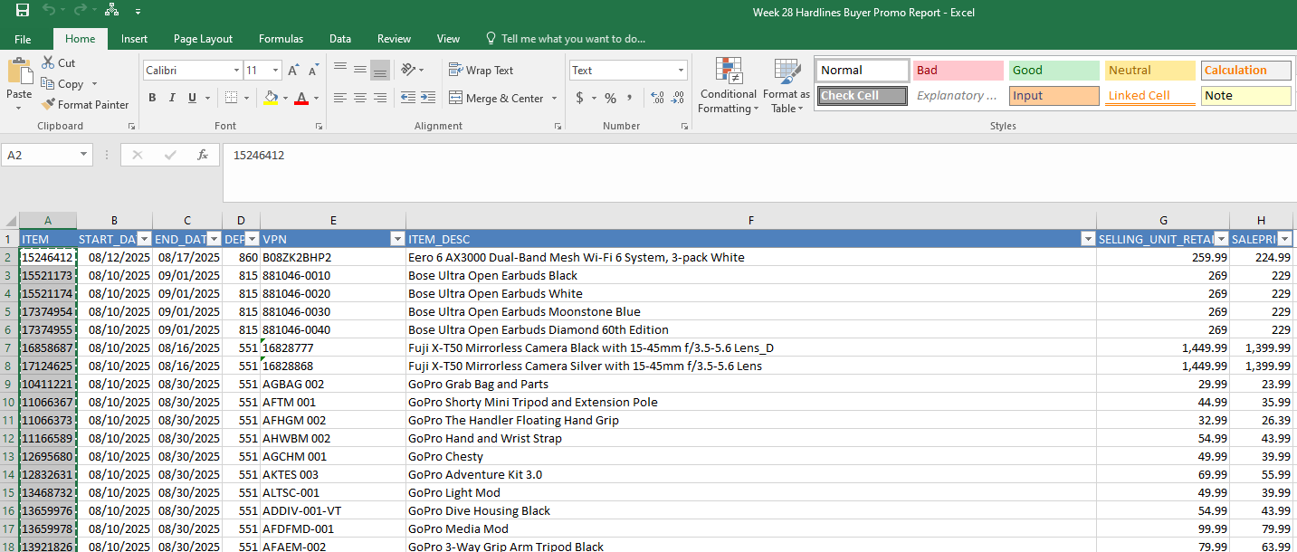
- Paste items onto “Blank Fact tag template, like so.
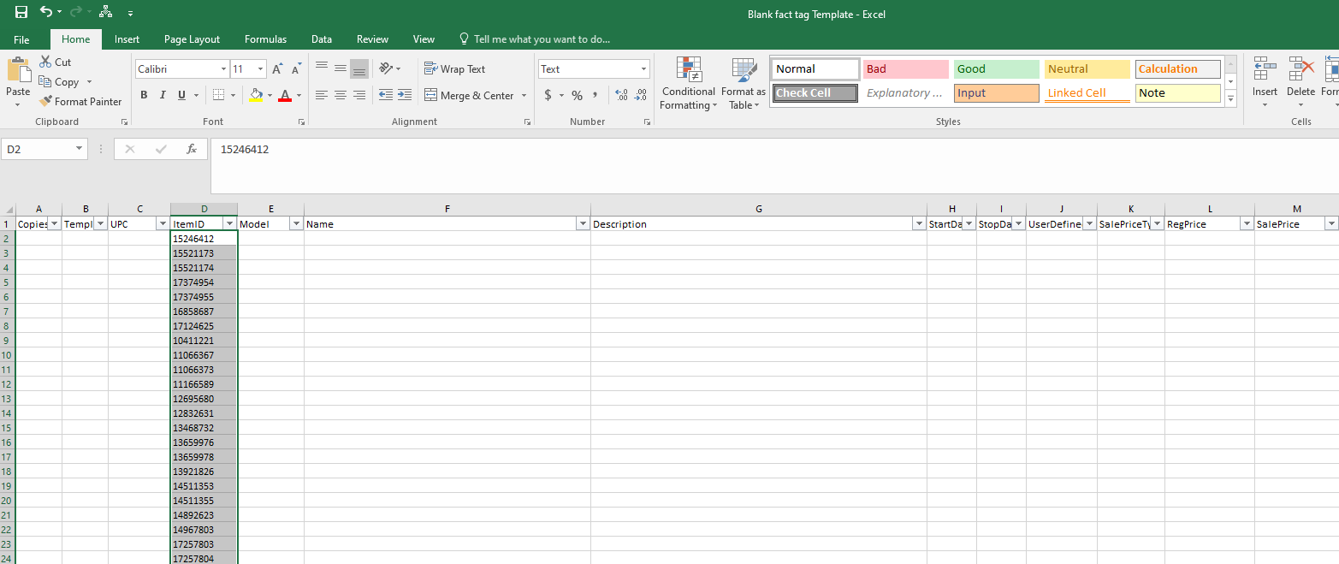
- =vlookup each column from “Fact tags all depts.” To “blank fact tags template”
- Note “NA” items that need fact tags create.
- Remove NA from list.
- =Vlookup retail price, sale price, and dates back from buyer promo report

- Copy and paste content from “Blank fact tag template” to “fact tags.”
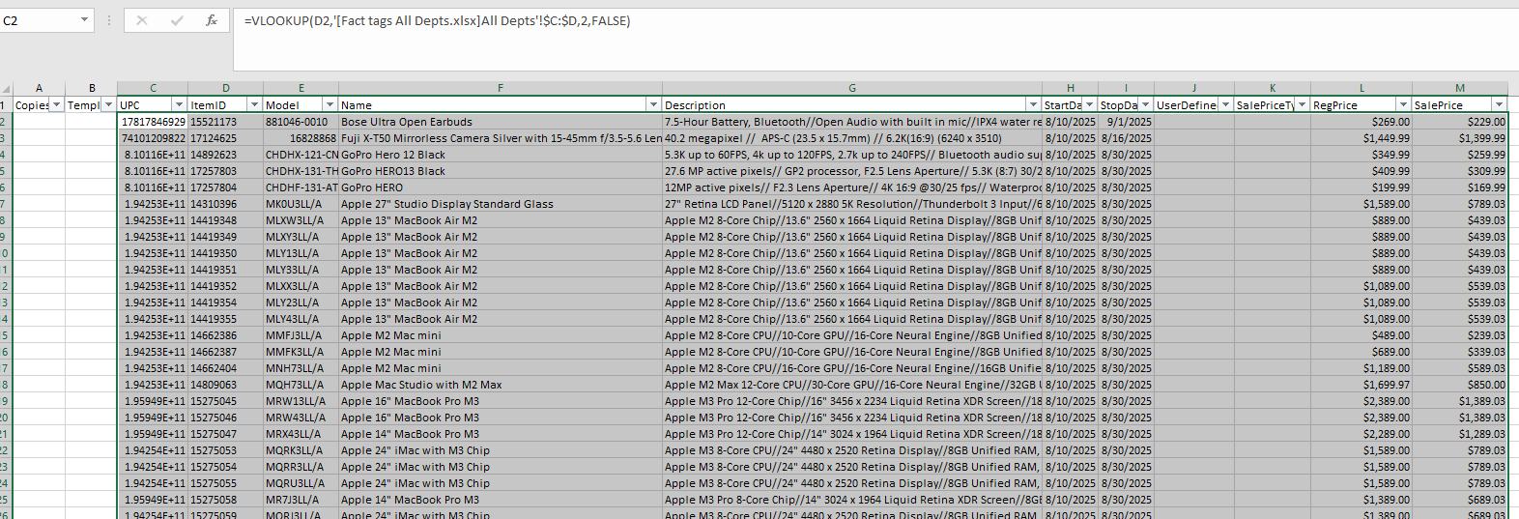
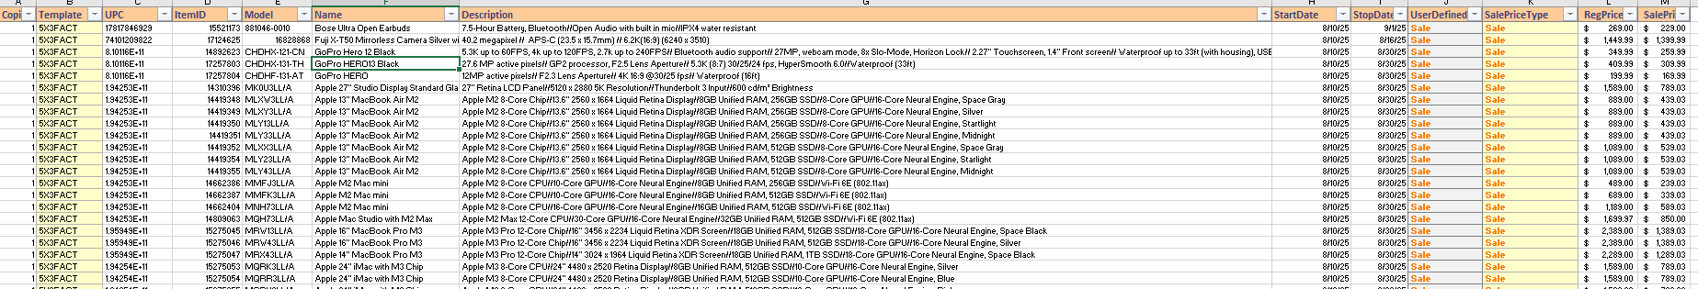
- From Rin inspector copy and paste UPC to the UPC column
- Change UPC & Name column to “Text.”
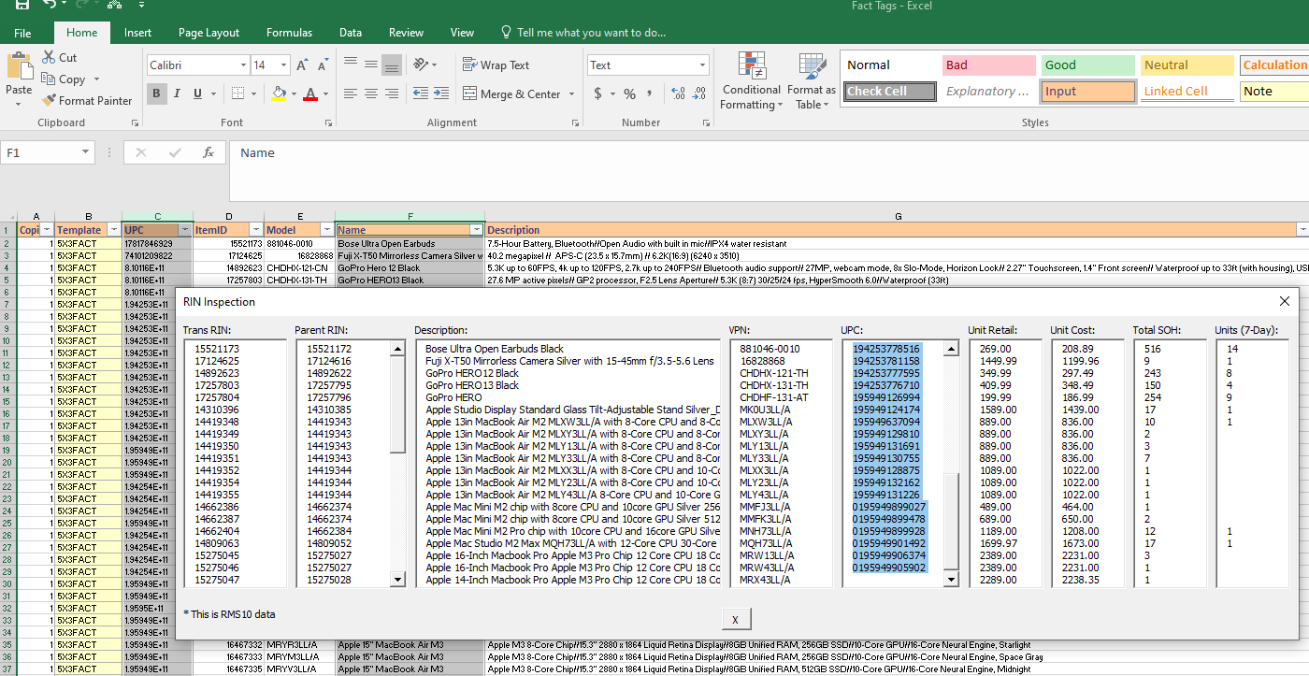
Save to here under naming convention
“Week 28 Unadvertised Electronics Fact Tag_99999_Promotion_SIGNS_HQ Distributed_20250810_20250816”
send to Plus Sign team.
See reference below.
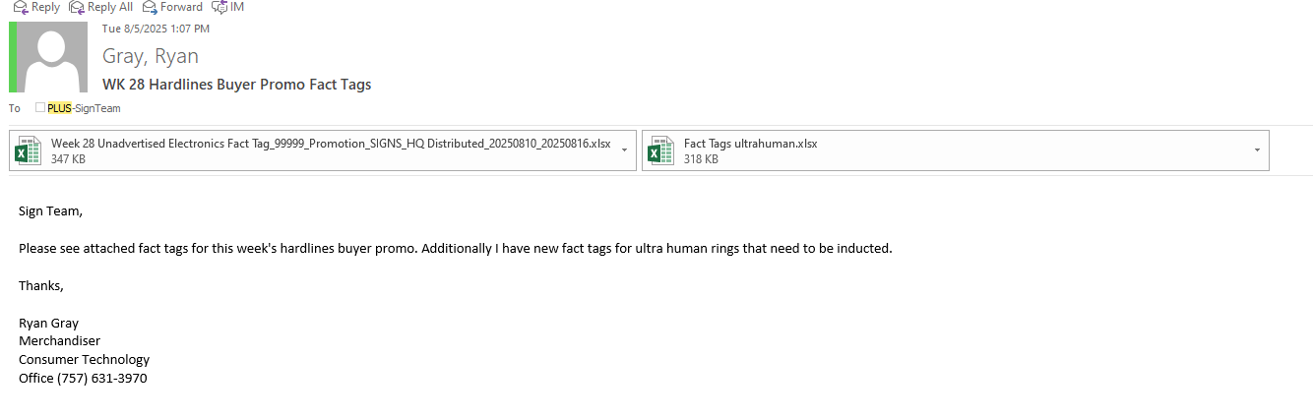

Top of the Document

Jenn’s Weekly Reports – March 2026
- Weekly Retail Detail
  - Before running any reports, visit https://intranet.nexad.nexweb.us/M/MS/Pages/Reports.aspx and ensure RDW/QS Sales are updated through Saturday of the previous week.
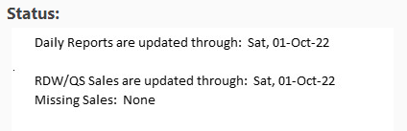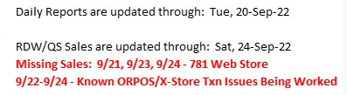
  - Open QuantiSense
  - Search “bakerje” to locate my folders
  - Open “My Reports”
  - Run “Weekly Retail Detail” for appropriate week (it takes a few minutes to run)
  - Export report results to Excel, save report to G:\Code_M\Code_MG1\MG1 15D Monthly and Weekly Reports\2026\2. March
  - Email file to Lisa Colvin, Tony Lynch, Brooke Allen, and Jason Wilmoth as below.
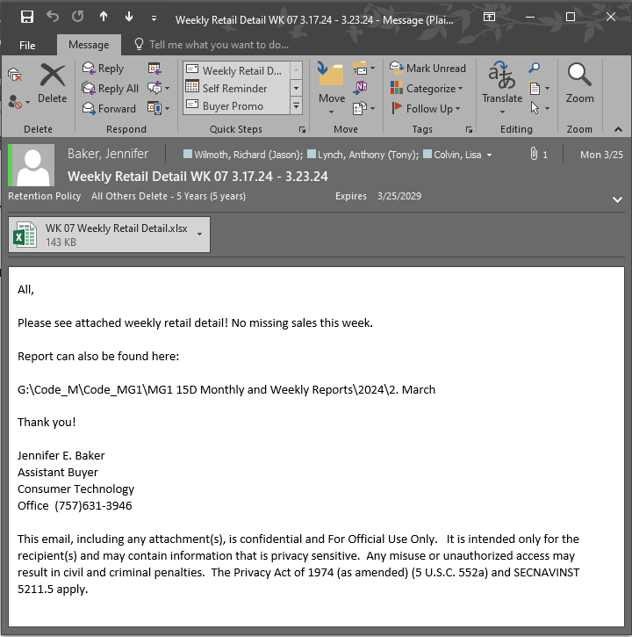
  - Separately, email to Karen Reno-Cobb, Eliot Fitzpatrick, Tom Dunbar, Jayla Pricer, and Chad Taylor.
- Vendor Reports
  - Open QuantiSense
  - Search “bakerje” to locate my folders
  - Open “My Reports”
  - Run “Weekly Vendor Sales Report” (you don’t have to change any filters or criteria)
  - Select vendor from the dropdown menu
  - Export to Excel (you can save it anywhere, you’ll just be copying and pasting the data)
  - Adjust column width/heights for readability
  - Find appropriate vendor file at G:\Code_M\Code_MG1\Group 257\Vendor Reports\2026 Vendor Reports
  - Add tab to master report from file with correct dates
  - Copy data from exported report to new tab
    - Acer and Asus are subsets of Synnex. For these:
      - Filter row 6 in the Synnex report
      - Select filter in Cell B6, search for the appropriate brand
      - This should filter the results to only the brand required
      - Copy to master report as before
    - WD and Sandisk are subsets of Ingram Micro.
      - For WD:
        - Filter row 8 of the Ingram Micro report
        - Select filter in Cell A6
        - Filter to the below RINs:
19650397
19650398
19650399
19650400
19650401
13660370
        - Copy to master report as before
- For Sandisk:
  - select filter in Cell B6, search for “Sandisk” and copy to master report as before
  - ADDITIONALLY, search for “Western Digital” and copy to master as before
  - Save and close, repeat with all vendors in file (see list below)
  - Email each file to their respective vendor group as below
Acer – pull from Synnex
Amazfit – 80341941 (Zepp North America, Inc)
Asus – pull from Synnex
Centon – 504865
D&H – 7911209
iBuyPower – 46871849 (American Future Technology)
Ingram Micro – 4919486
Samsung – 7948
Sandisk – pull from Ingram Micro
SPA – 89144831
Synnex - 112375758
Ultrahuman – 68073601 (Deal Rise, LLC.)
Western Digital – pull from Ingram Micro

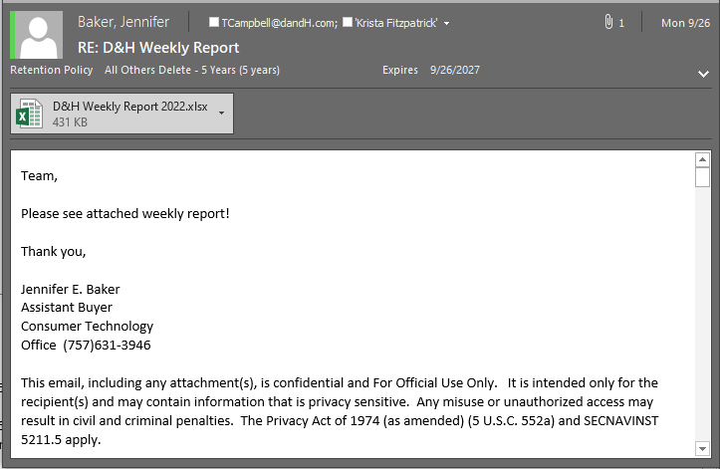

Top of the Document

CT - People of Contact

